**App Development documentation**

**University of Arts London**

**Table of contents**

***Introduction ............................................................................................................................................*** 2

***Research process ....................................................................................................................................*** 2

*1. State of independent cinema after the pandemic with the graphs that justifies my motivation to*

*create the app ...................................................................................................................................* 2 *2. Community explained ...................................................................................................................* 4 *3. Competitors analysis. ...................................................................................................................* 5

*5. Similar apps ..................................................................................................................................*7

***Design ....................................................................................................................................................***11

*Prototypes ................................................................................................................................*11 *Iteration process……………….................................................................................................*15

*App Icon & Name ......................................................................................................................*18***Future Implementation ......................................................................................................................***18 ***Bibliography .......................................................................................................................................***19

**APP DEVELOPMENT DOCUMENTATION**

Link to the git repository: https://git.arts.ac.uk/22046145/appdev_/tree/main

Link to the MockUP plus: https://rp3.mockplus.com/rps/B095Gw9mLC/KomfM7HrLK

Link to UserFLow:

https://www.canva.com/design/DAGH0baq9AQ/7OeSjEFGX1xLRUhW2GlwDw/edit?utm_content= DAGH0baq9AQ&utm_campaign=designshare&utm_medium=link2&utm_source=sharebutton

*Introduction*

The idea behind my app is to support independent cinemas in London. After the COVID-19, the whole film industry has suffered greatly. While the big cinema chains still try to make it work, some of the small independent cinemas struggle to survive. My idea is to create an app that will show all of the independent cinemas across London, so that the user can contribute and support the independent cinemas. The aim is also to explore “hidden gems” of London cinemas. The app is coded in Swift language, showing main functionality and overview of the design. My idea has undergone several steps of iteration.

*Research process 1. State of independent cinema after the pandemic with the graphs that justifies my motivation to*

*create the app*

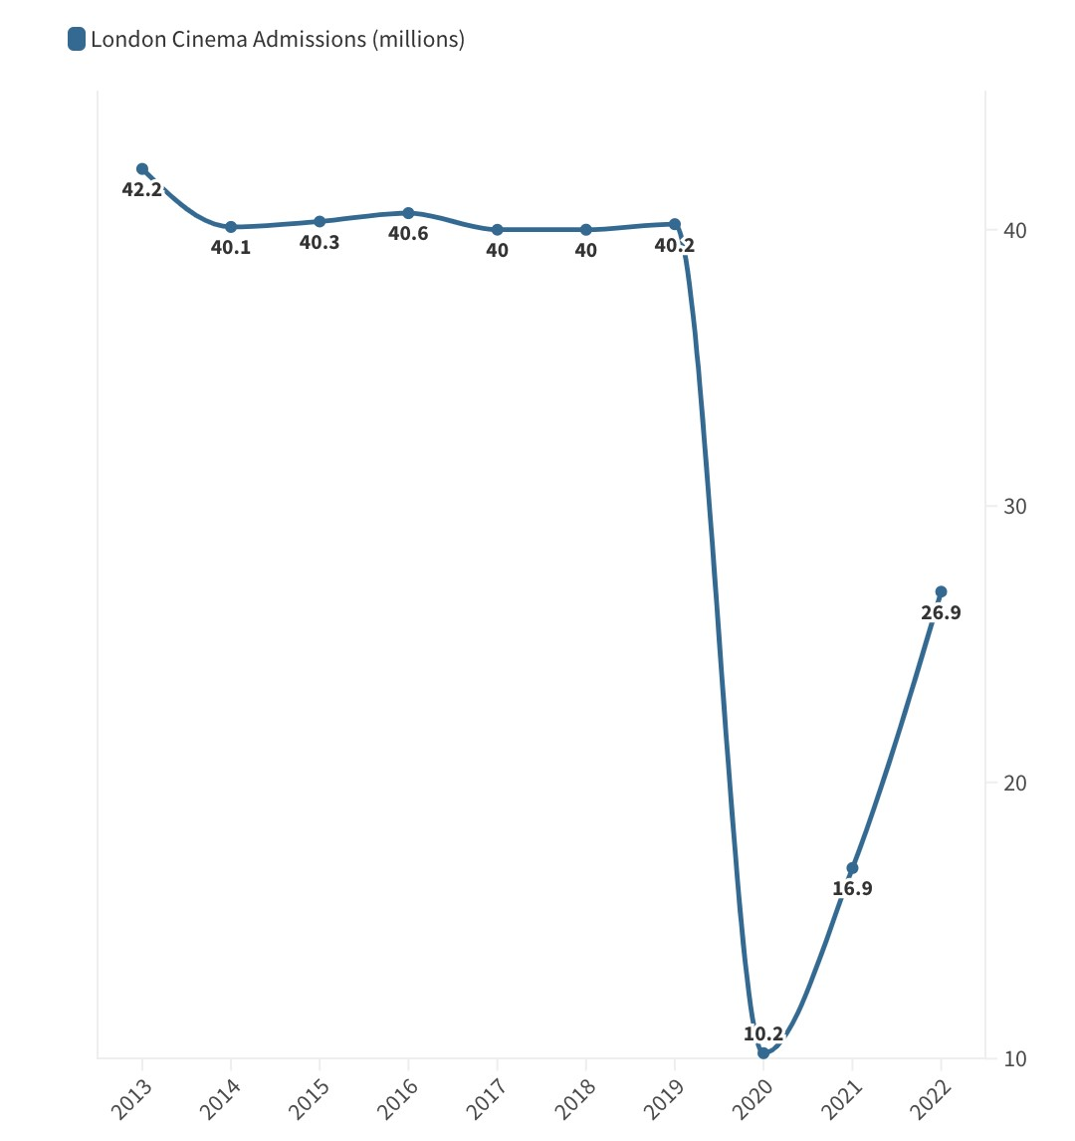The independent cinema sector has faced various obstacles over the past few years. 2020 saw UK cinema admissions fall to an all-time low, crashing from 176 million in 2019 – comfortably the highest admission numbers since 2013 – to just 44 million, according to the British Film Institute. (Londoner, S.E. (2023)). Besides, as a result of lockdown, the streaming services have evolved to be a great competitor of the cinema industry. For example, Disney+ has reached its goal of 90 million global subscribers four years ahead of schedule. As a result, a lot of venus have closed and the numbers are expected to go lower.

In 2023, the film industry remained in a state of flux following the Covid-19 pandemic and its attendant reverberations. Cinemas have had to cope with changes to operating models, shifts in audience behaviour and the rise of online streaming, with all these factors liable to future fluctuations. There are also obvious

*Figure 1 UK cinema admissions* economic challenges, with reduced availability

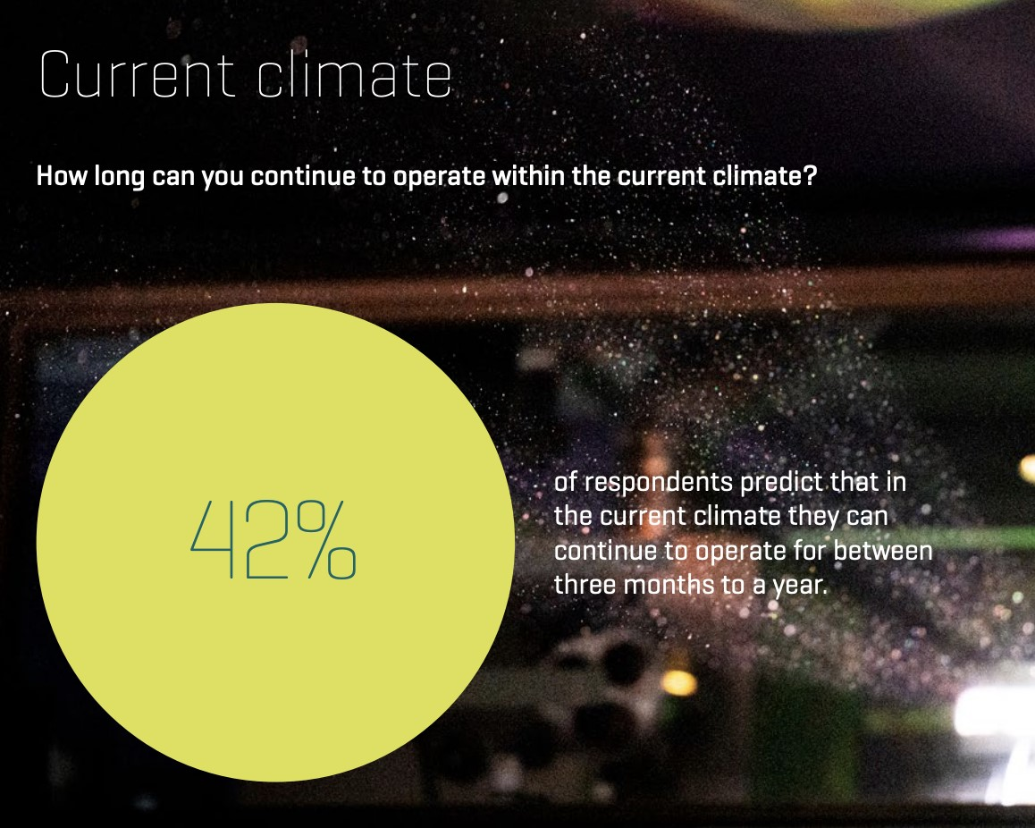of public funding, a cost-of-living crisis, and a rise in energy prices, all of which have impacted the sector and seen the recent closures of key independent cinemas. Venues forecast operating at a loss this financial year (2024) and as shown the past two financial years would have also been loss making for many. If this trend continued for further years, it could potentially lead to closure of some of these venues. The impact of the loss of even a small number of independent cinemas would be felt beyond the communities that they serve, as their closure could seriously impact the viability of distributors releasing independent films.

Nevertheless, the industry is recovering slightly after the pandemic, but it will require a lot of time to get the

revenue back to the state as it was before Covid-19.

*Figure 2 Results of the survey*

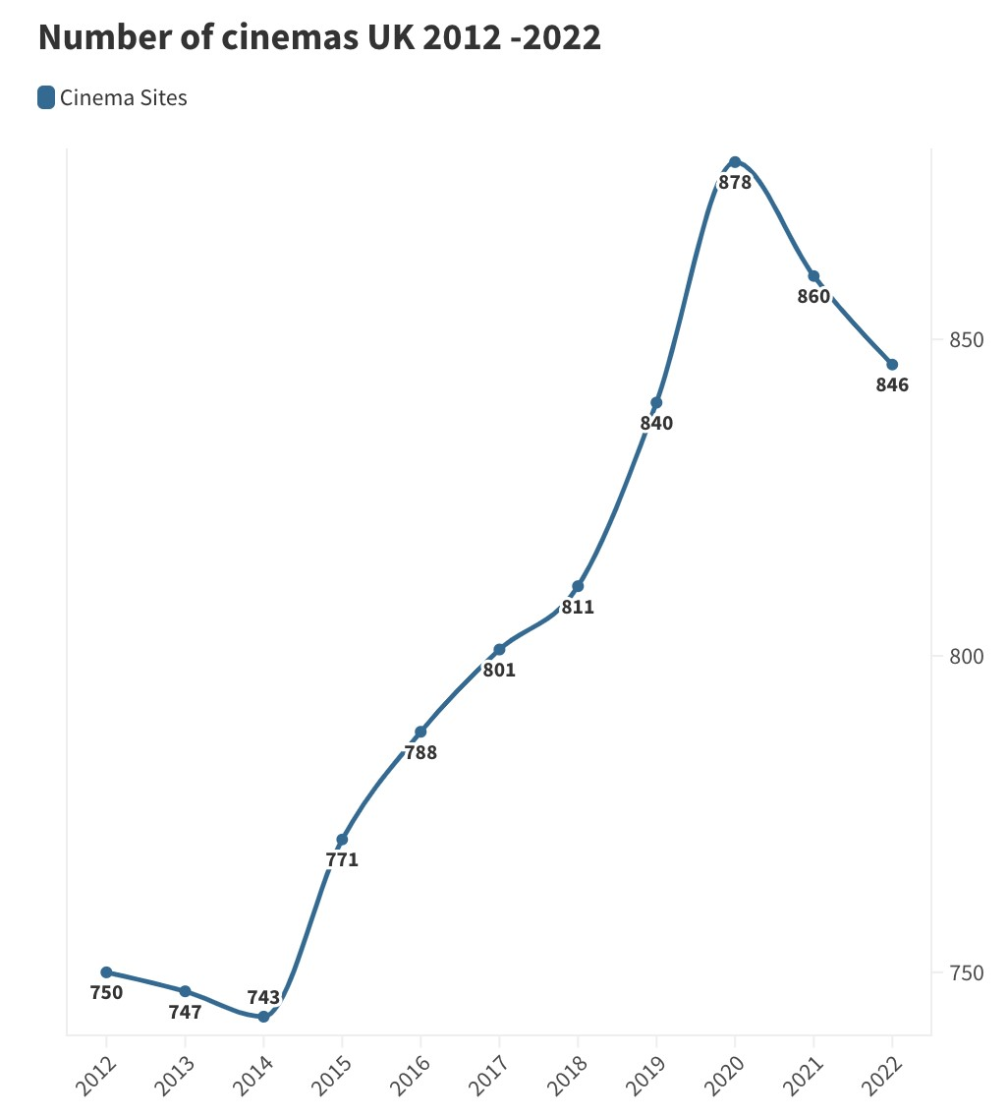Independent cinemas serve as vital community hubs for a diverse range of audiences, including those who are elderly or socially isolated and often are a key cultural asset in areas where there is otherwise low cultural provision. Their operations have a wider positive economic impact on the cities, towns and rural areas where they are located. Most independent cinemas are significantly invested in being a cultural space, reaching new audiences, showing a broader selection of films, focusing on environmental sustainability, and improving accessibility. (Independent Cinema Office (2023))

The survey was taken by the ICO with the help of BFI about the current state of the local independent cinemas,their financial situation and their worries about the next few years of operating.

*Figure 3 Number of cinemas in UK between 2012-2020*

The results show that within the current circumstances, 42% of the respondents would only be able to operate another year or less. 50% of the respondents are needing the financial support, with organisational grants and VAT reductions being the most desired forms. As a result, the majority's main concerns are increased cost, uncertainty around film releases, lack of admissions and a loss of revenue.

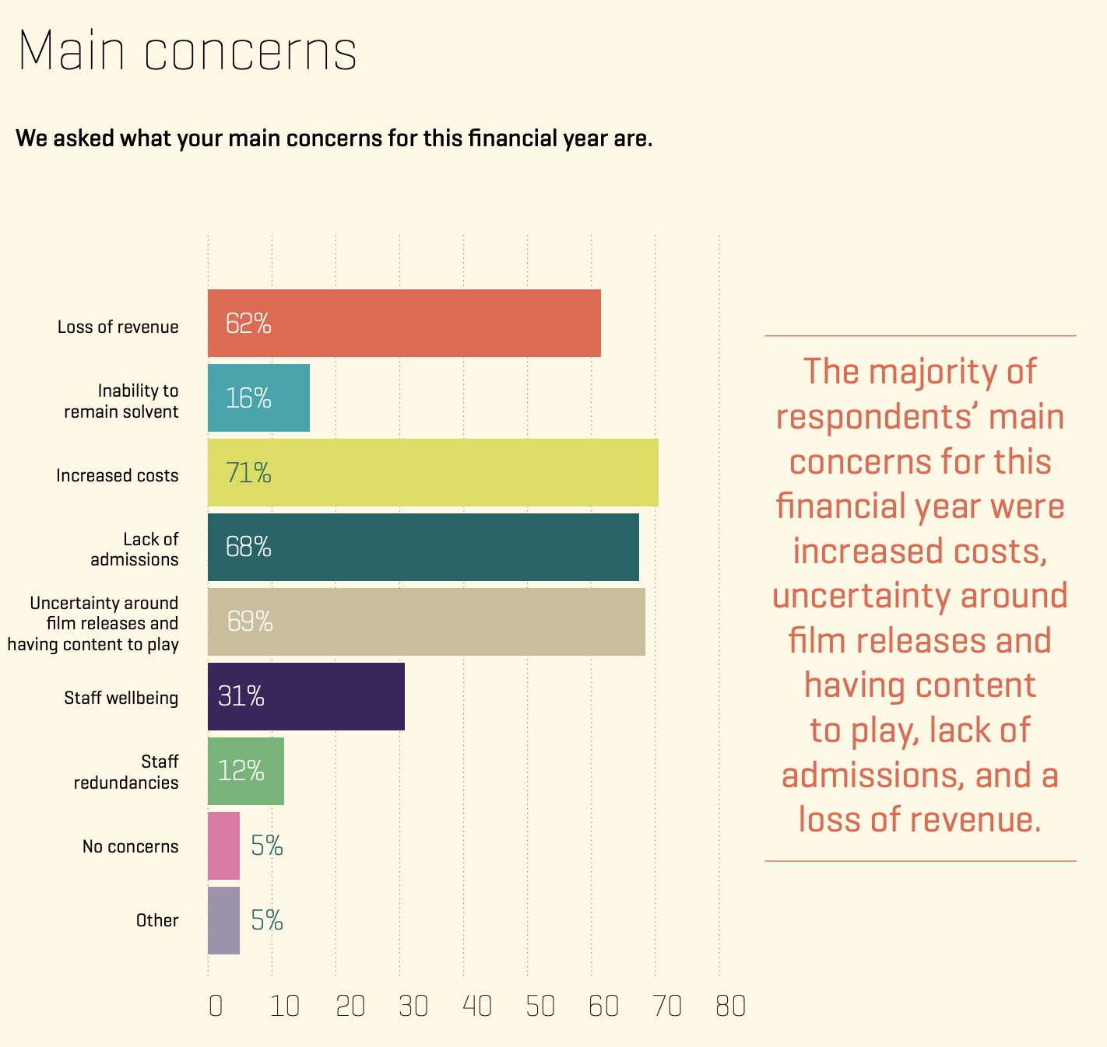“*In a time of great change in film, independent cinemas are the lifeblood of the industry.*” (Chrysostomou, 2023). The reason why independent cinemas are vital community hubs is because they have “character”. They are all different, often taking their own approaches to the interior styling. The beauty of an independent cinema is that the history of the building they are housed in can also be taken advantage of. Across the country there are beautifully old structures that have been repurposed for films, with all of that natural charm blending into the building’s new role. It’s vital that these impressive structures and their innovative interiors are protected. Many represent a rich tapestry of Britain’s film industry. They

*Figure 4 Results of the survey* are venues that can host tailored events for all

ages, providing experiences that guests can take with them forever. They are great for local business, with many indie cinemas playing adverts for regional companies, thus helping with trade. Independent cinemas provide a unique sort of experience unlike the big chains, accompanied by big prices, and a lack of genuine charm. That is why I decided to focus on the independent cinemas for my project Chrysostomou, G. (2023).

*2. Community explained*

*What is a community?*

Gusfield (1975) distinguished between two major uses of the term community. The first is the territorial and geographical notion of community—neighbourhood, town, city. The second is “relational,” concerned with “quality of character of human relationship, without reference to location”. According to McMillan and Chavis there are four elements to the definition of community in the “relational” sense. The first element is *membership.* Membership is the feeling of belonging or of sharing a sense of personal relatedness. The second element is *influence,* a sense of mattering, of making a difference to a group and of the group mattering to its members. The third element is reinforcement: *integration and fulfilment of needs.* This is the feeling that members’ needs will be met by the resources received through their membership in the group. The last element is *shared emotional connection,* the commitment and belief that members have shared and will share history, common places, time together, and similar experiences.

*What communities are you a part of?*

To determine which part of the community my app is going to focus on, I decided to shape the communities I am part of. All of the communities I am part of have a different density of the relationship. If I consider the community in a broader sense, I am a part of the international student community, but it is so broad in London that I can hardly feel that I am a member of it. In terms of my hobbies, I am a part of the yoga community. I have a membership that allows me to attend weekly yoga practices. Besides, the company provides some social activities: such as running clubs before yoga practice or wine-drinking sessions to get to know each other. In terms of university communities, I used to be a member of a ceramic society last year. I also had a membership that allowed me to participate in the social events that bond the members of the community as well as the ceramic workshops.

*Which community do you want to create an app for? Why?*

The aim of the project is to create an app that is aimed at a particular community. The community I am aiming primarily for is film enjoyers. Me, as an international student, who loves to watch films, took a lot of time to gather information about all the events about the independent films and the venues themselves in London. The idea itself came to me based on my own experience not being able to attend the desired events because of lack of information. At the start, the app focuses on the community of film enjoyers, but it is possible that the app would boost other people’s interest in independent cinemas.

*3. Competitors analysis.*

The cinema industry in London is very developed and it has a variety of things to offer. After analysing some of the cinemas in London, I managed to extract some of the similar features. I took into consideration both the independent cinemas and big chains to find out their policy about retaining loyal customers.

1. *Subscription/membership*

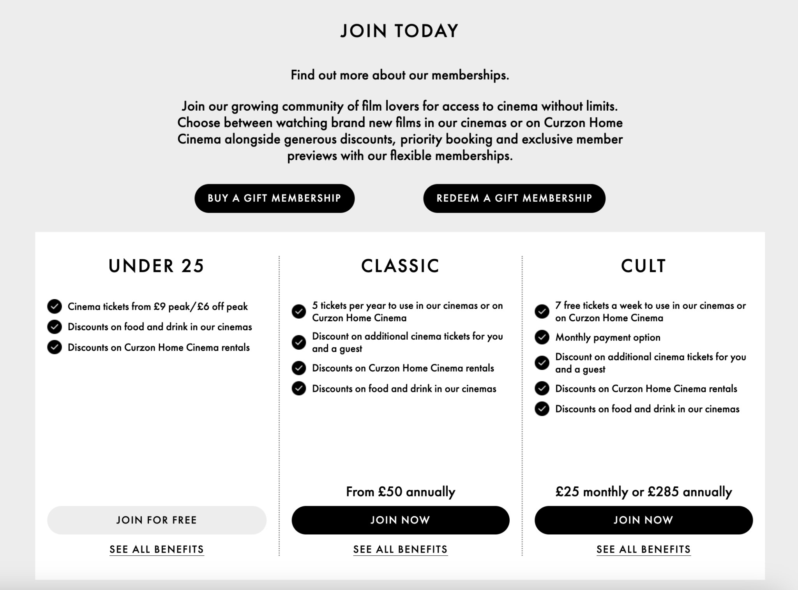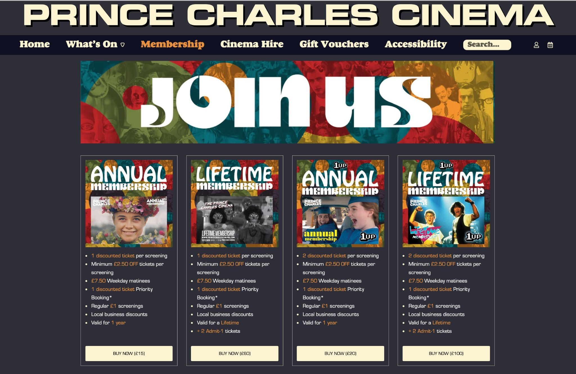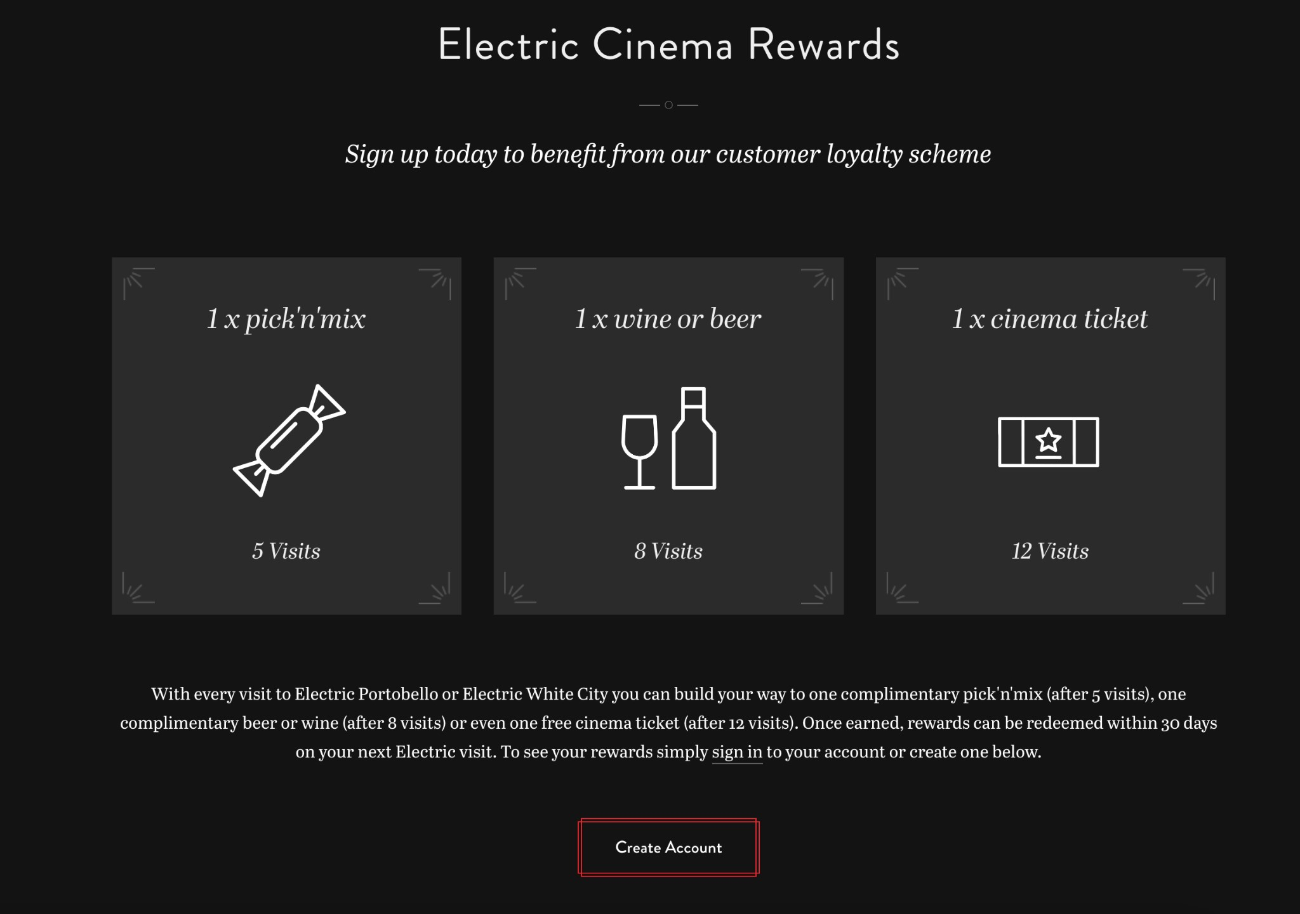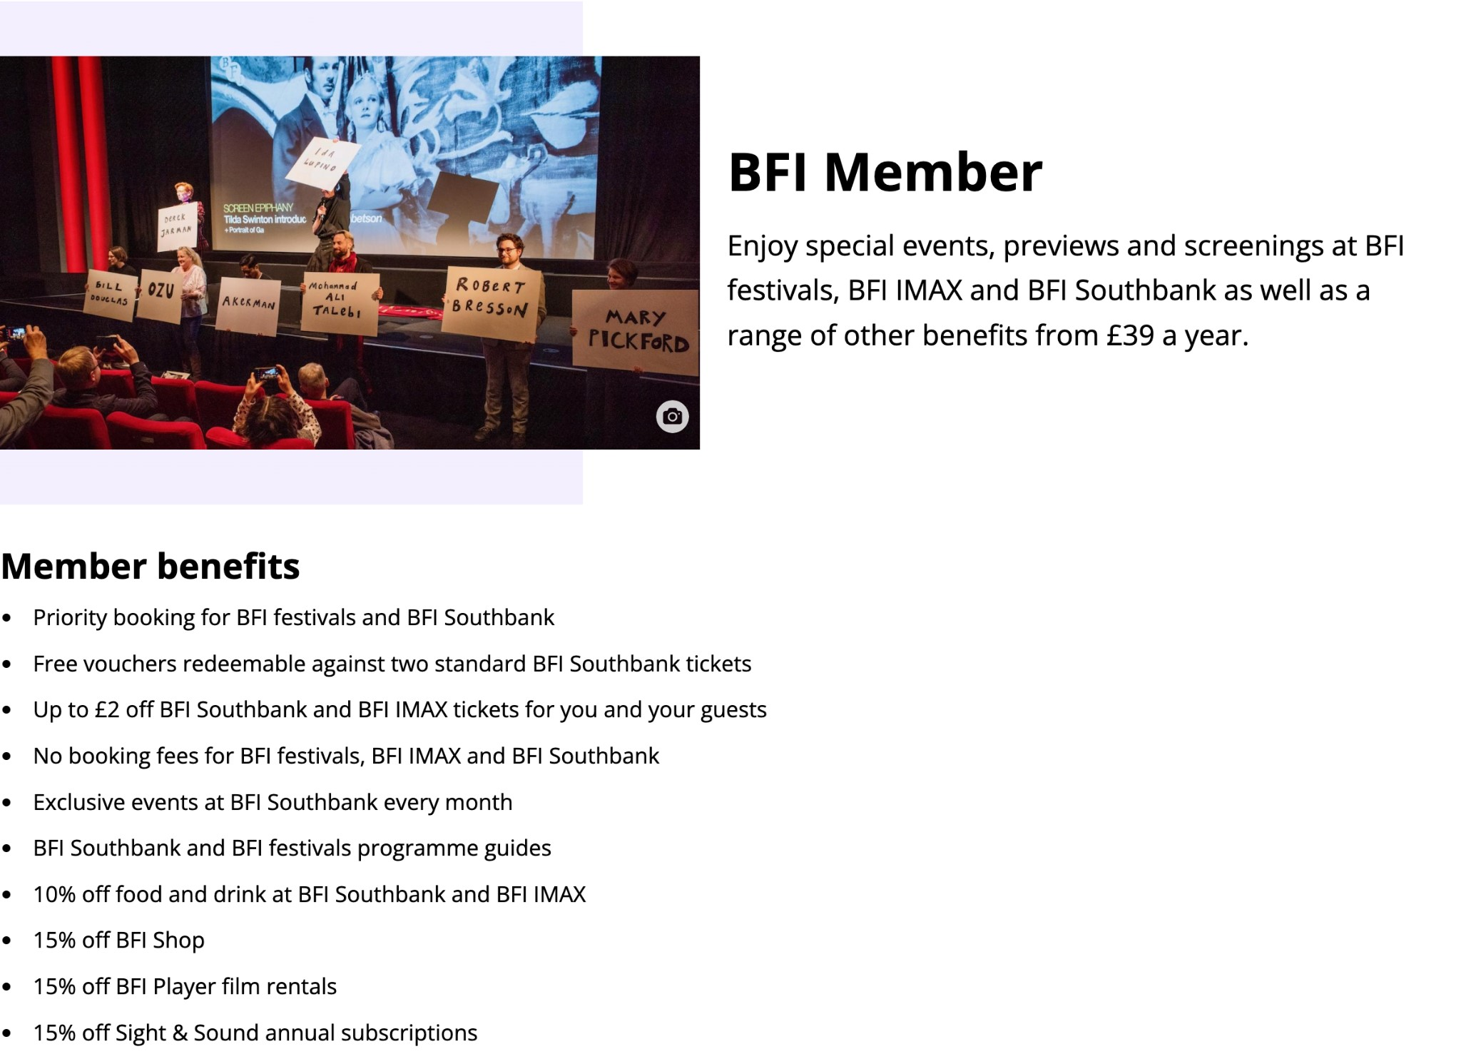

One of the main features of all of the cinemas that I analysed is the membership/subscription/reward system. There are different types of memberships that provide different levels of benefits. In the example of the Electric cinema, the reward system. This is probably the best way to retain loyal customers. Membership fees provide a steady stream of income that can help buffer against the financial uncertainties of independent cinema operations. Memberships provide access to a broad range of events that are offered by independent cinemas, such as early screenings or special Q&A sessions, which can generate additional revenue and foster the community sense.

1. *Newsletter*

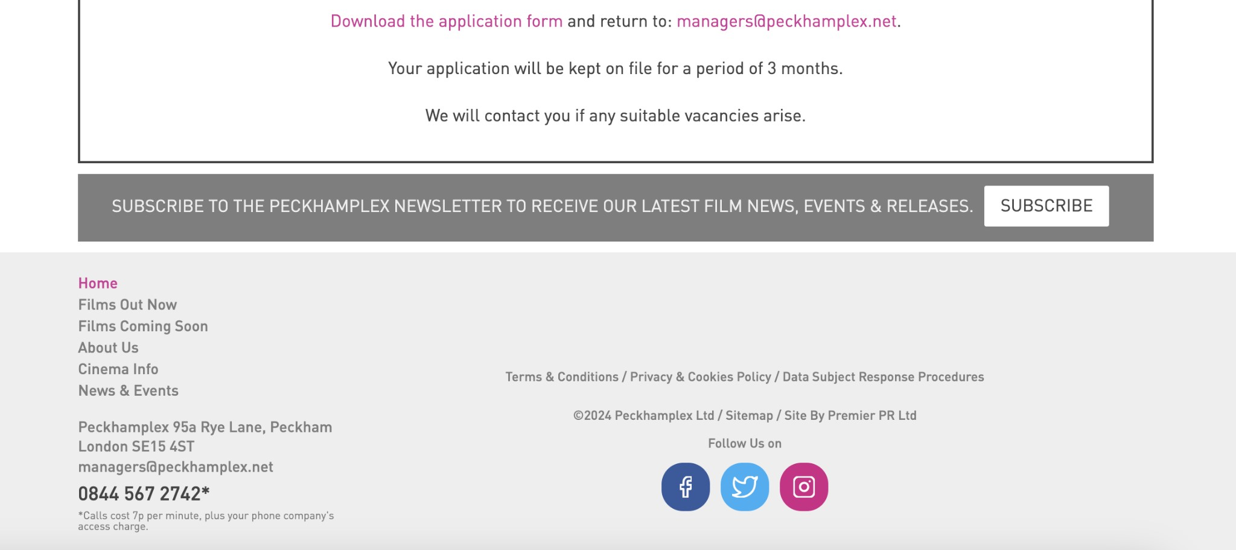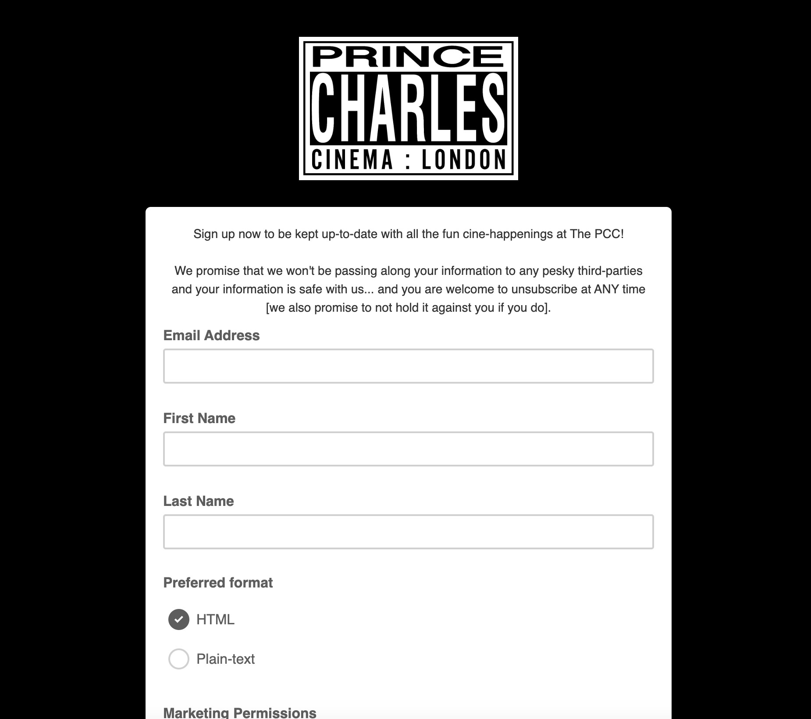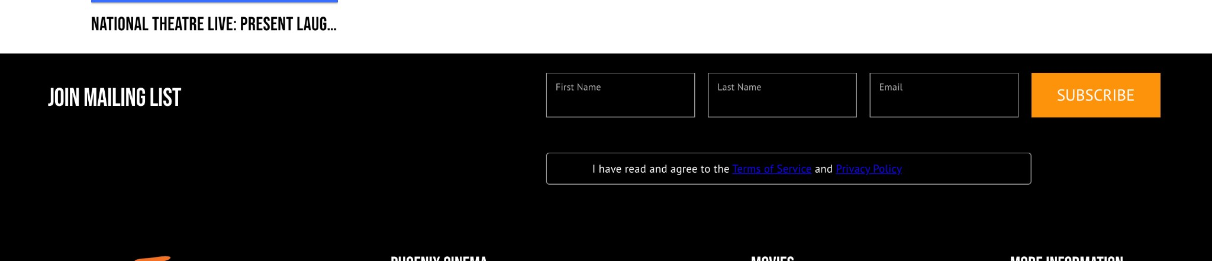

Another feature is a newsletter. Newsletter could be either personalised or connected to the account of the member. Usually, they consist of a weekly digest of what is showing in the theatre and what other events are happening.

1. *Own production : podcasts, news, articles*

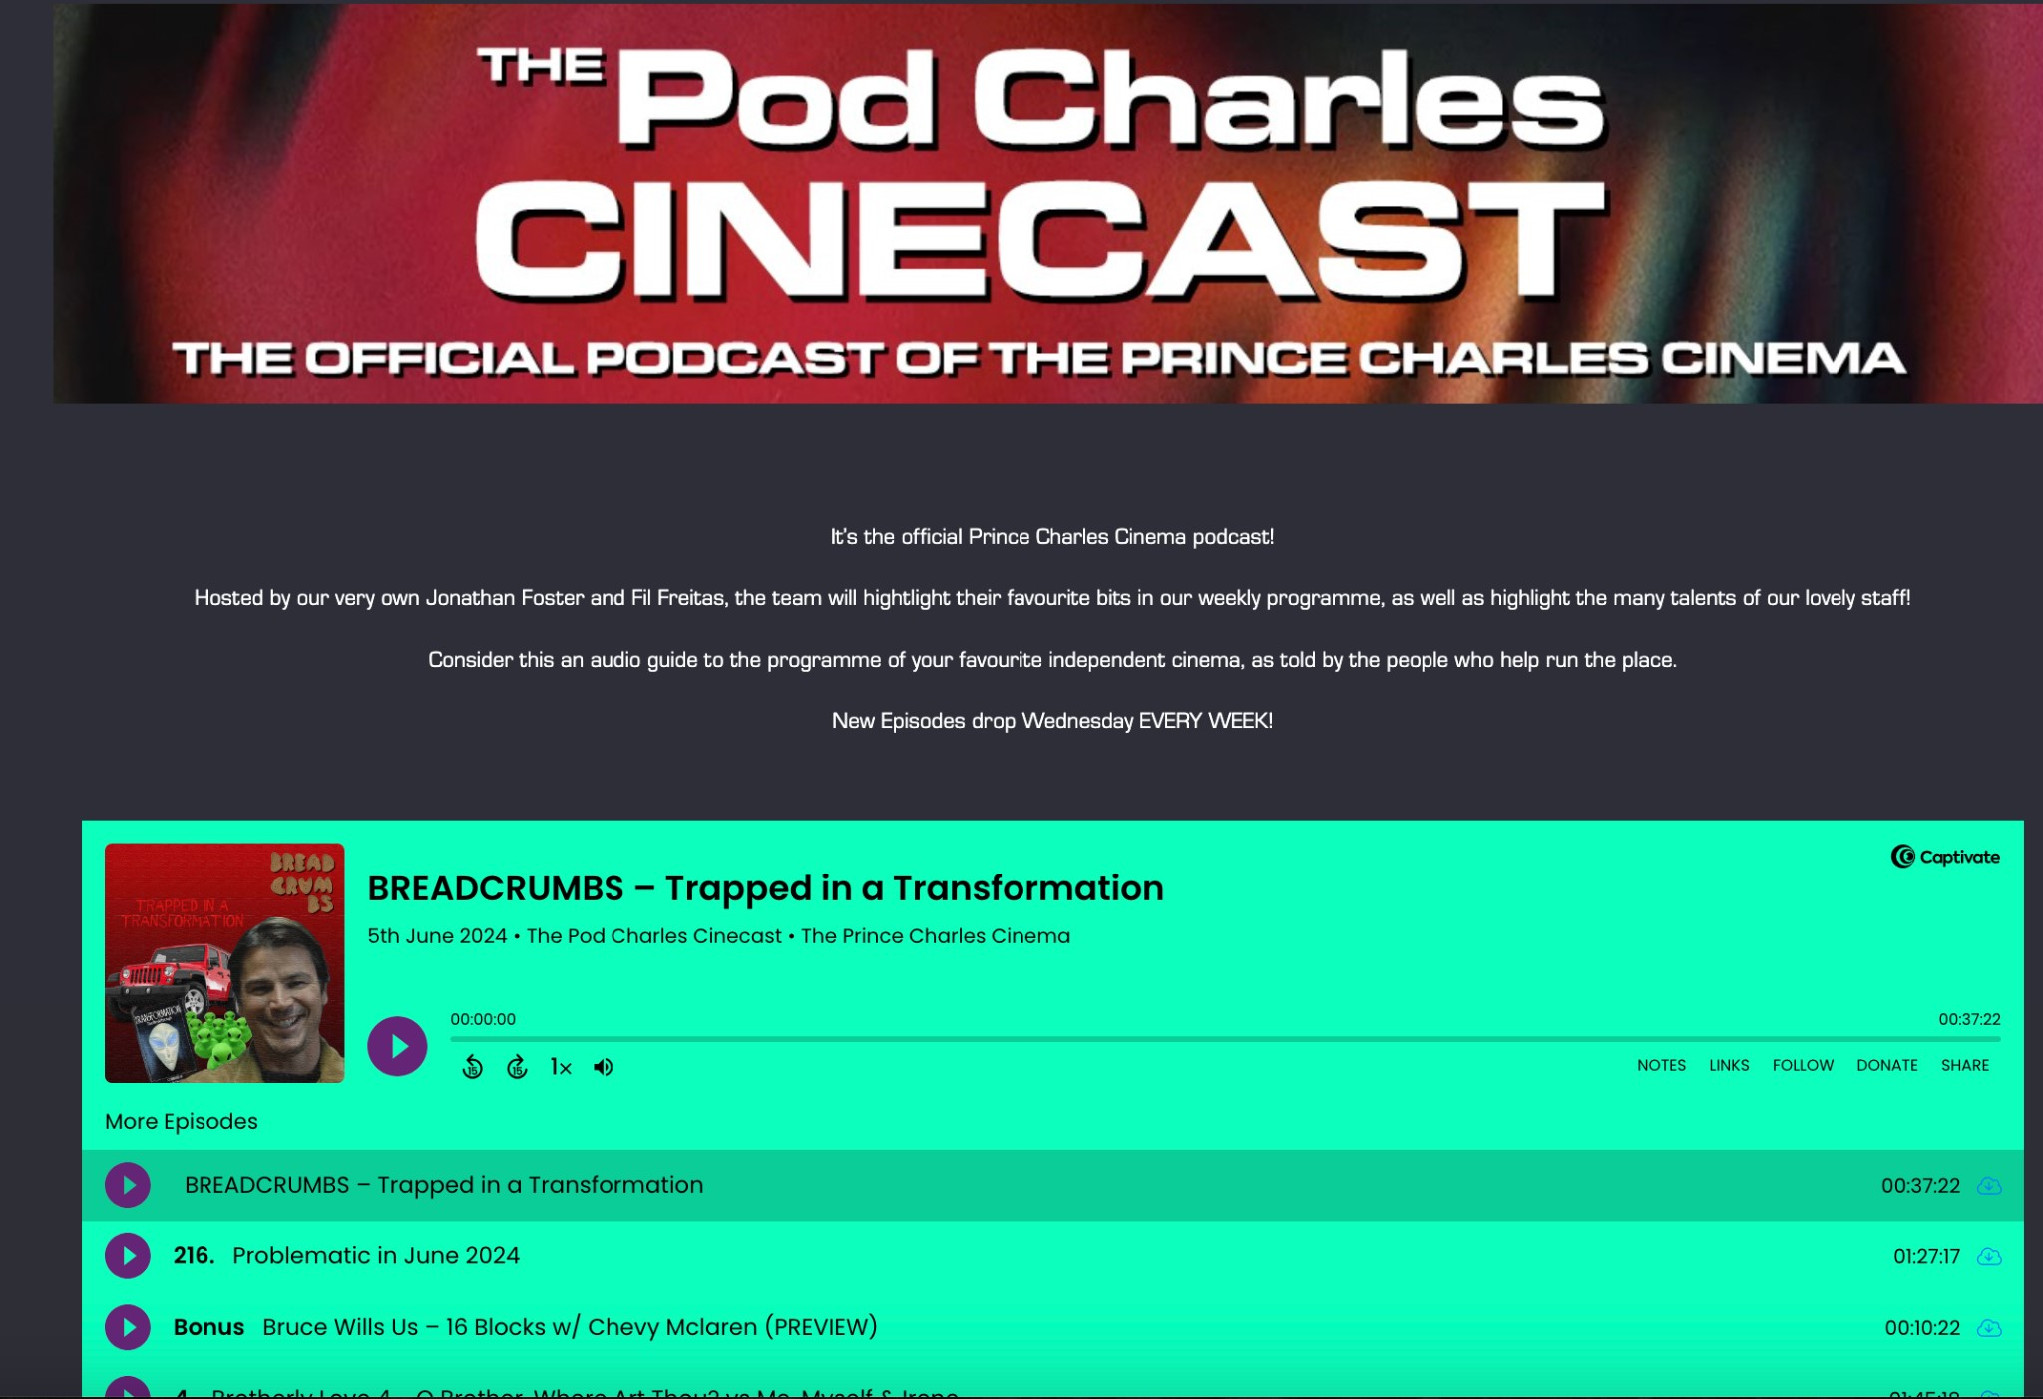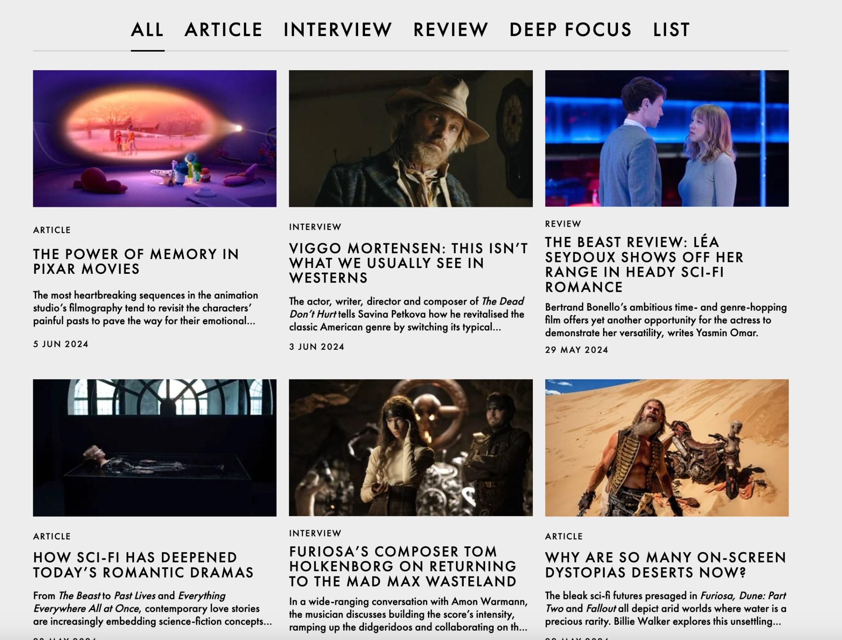

Some of the cinemas have their media production: news, articles, interviews, podcasts. This is a great way to keep the audience engaged. [https://princecharlescinema.com/podcasts/]

1. *Special events: Q&As*

Some of the cinemas provide special events, like Q&A with the directors, or movie nights. Sometimes these events are only available for the members of the cinema, sometimes it is available for everyone. This type of event makes the cinemas inclusive and stand out from each other.

A lot of cinemas show re-releases screenings: a screening of a film that is already available online. I think this is a great way to engage movie lovers, for example last year BFI showed 100 best movies of all time and I got to see the films of my favourite directors on a big screen.

1. 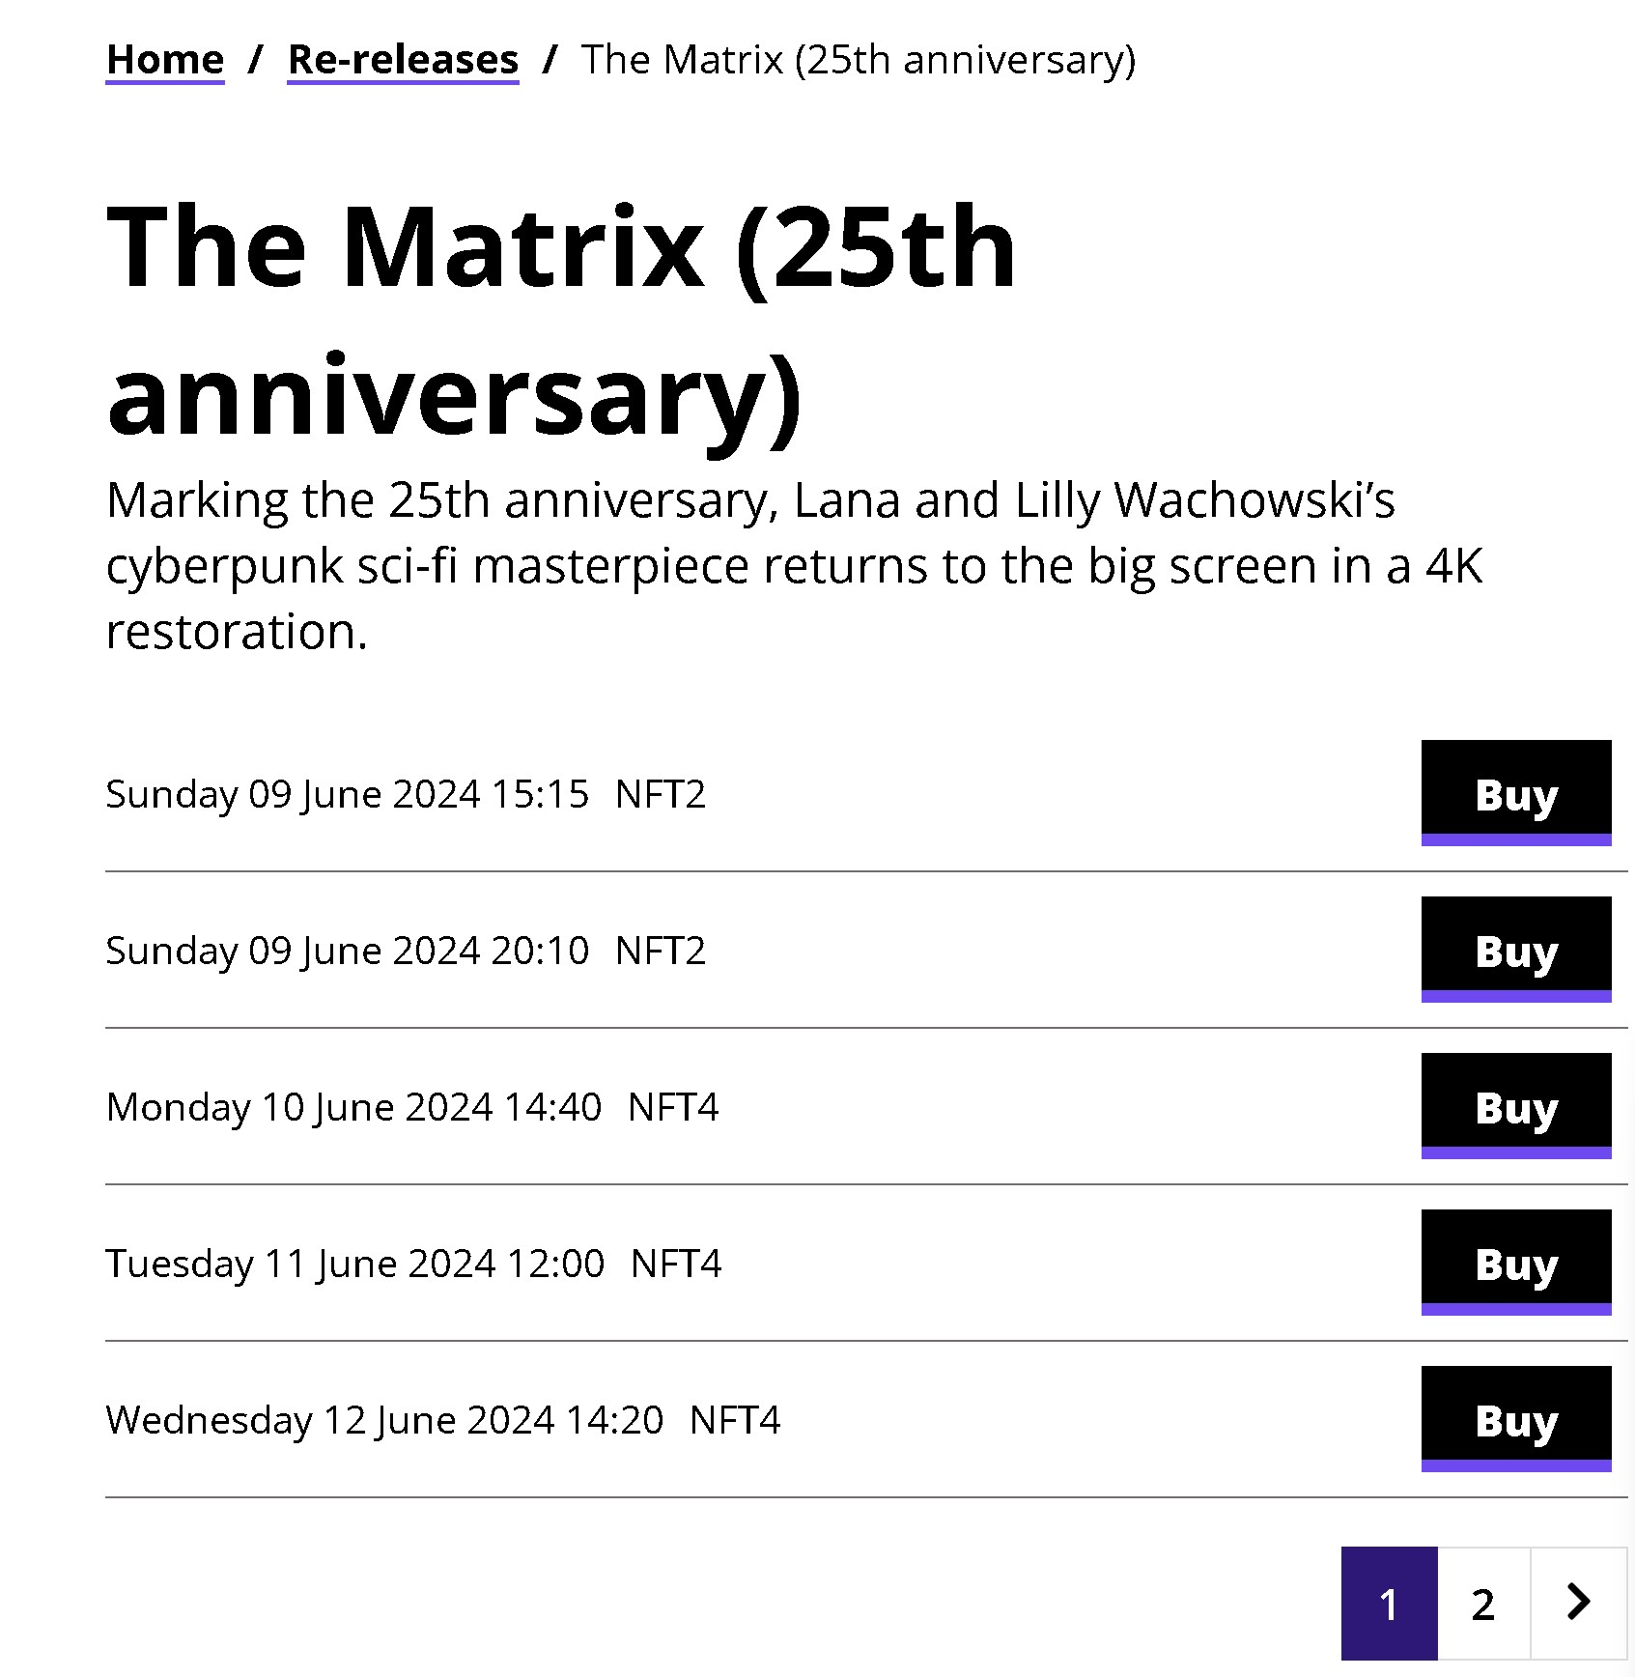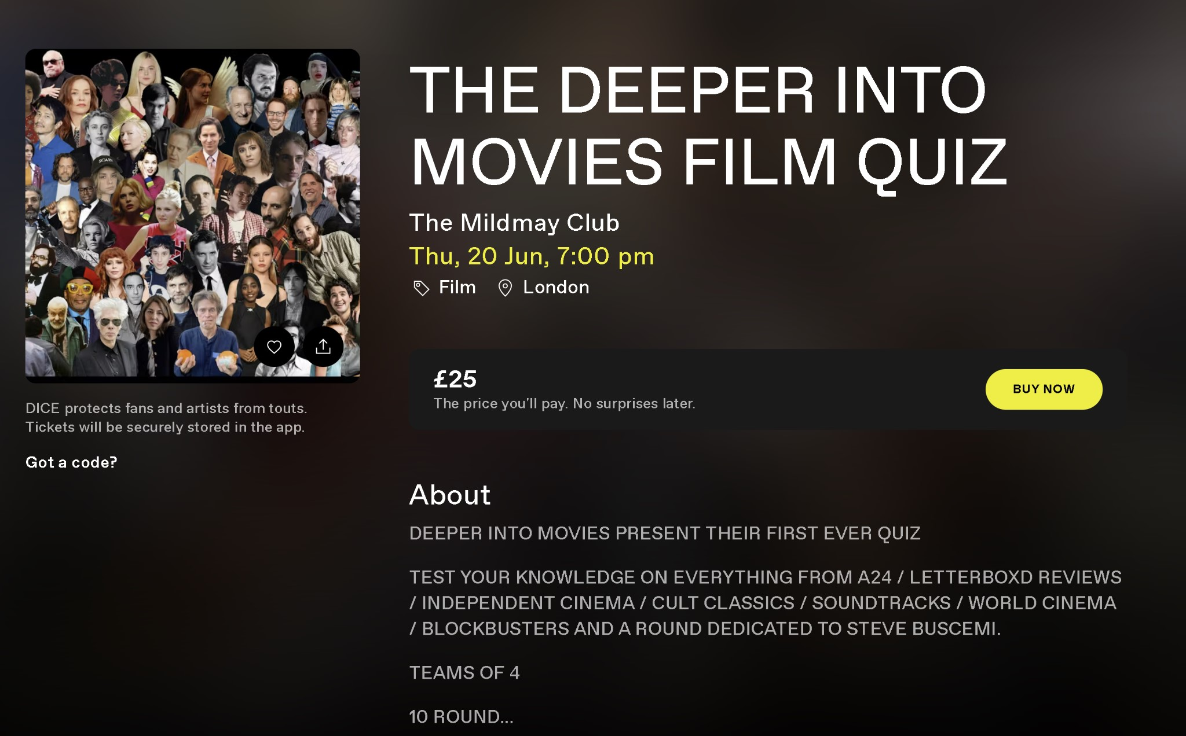*Similar apps*

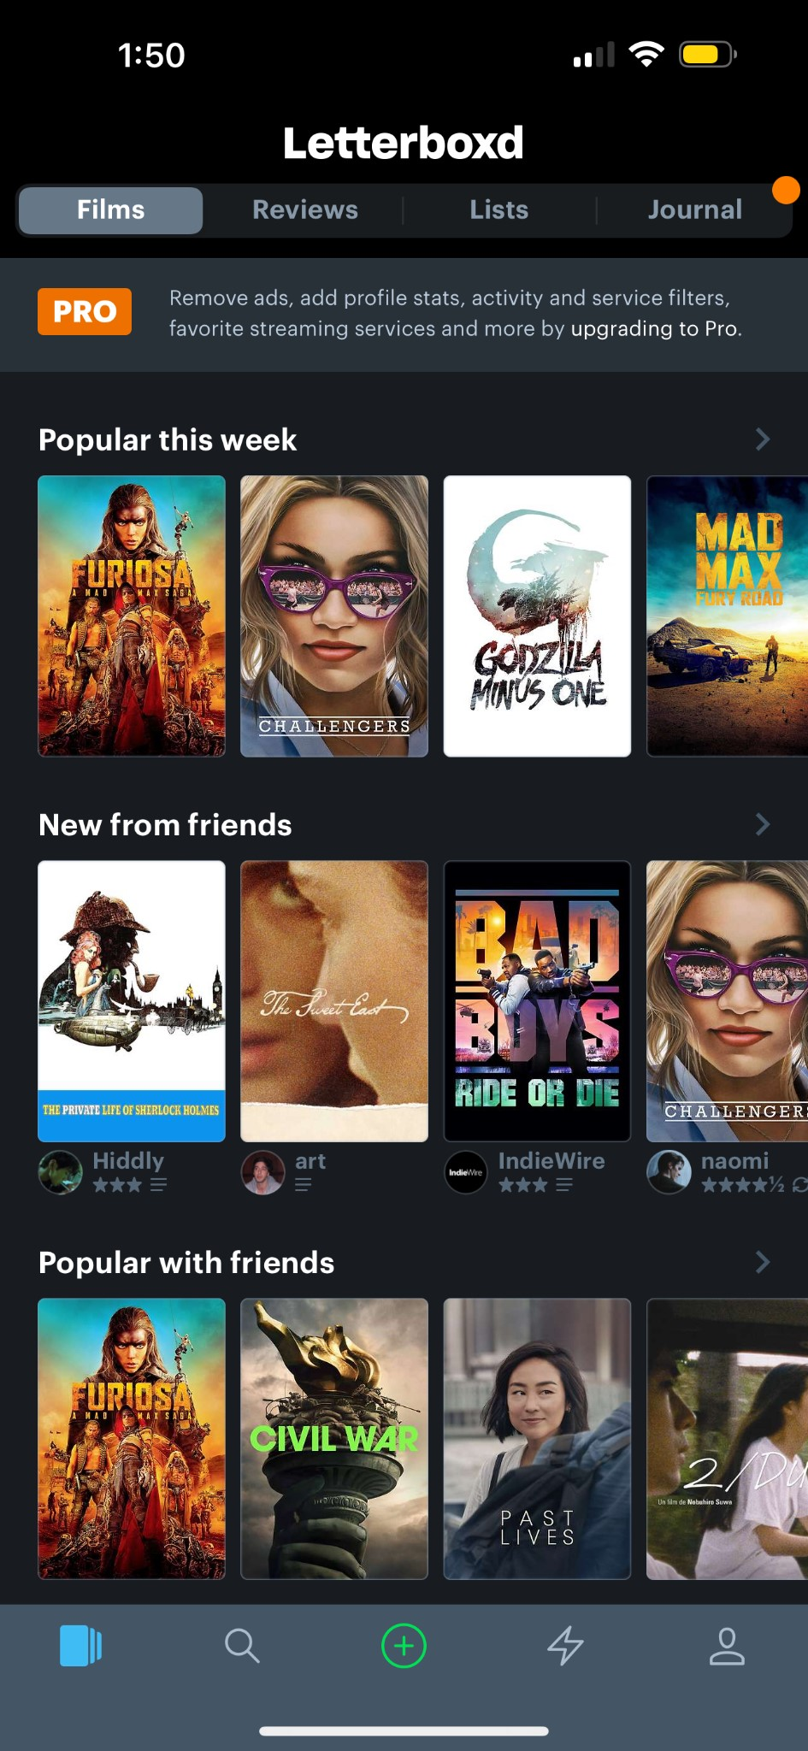In terms of similar apps to draw inspiration from, I explored 2 apps and their user flow. The first app that I chose was Letterboxd. Letterboxd is a global social network for grass-roots film discussion and discovery. You can use it as a diary to record and share your opinion about films as you watch them, or just to keep track of films you've seen in the past.

The main page of the app consists of a navigation bar on top and 3 parts with the same pattern of scrolling. The navigation Tab contains “films”, “reviews”, “list, and journal” which allows users to switch between different sections of the app. The app also has a pro version of the app which gives users more access to the functionality of the app. The main part of the page is divided in three parts: section “popular this week”, section “new from friends” and section "Popular with friends. All three section have common features:

* + Horizontal scroll of movies
  + Large, eye-catching thumbnails

The bottom part of the page consists of a footer navigation bar with navigation icons that serve different functions of the app: library, search, add new content, activity feed, and user profile. These icons provide quick access to the main features of the app.

In terms of the design elements of the app, I highlighted these:

* + Dark theme: The overall colour scheme is dark, providing the cinematic and immersive user experience.
  + Visual Hierarchy: Large thumbnails and posters dominate the screen to attract user attention and highlight the visual nature of movie content
  + User interaction: horizontal scrolling sections allowing users to swipe through a wide variety of content without overwhelming the screen

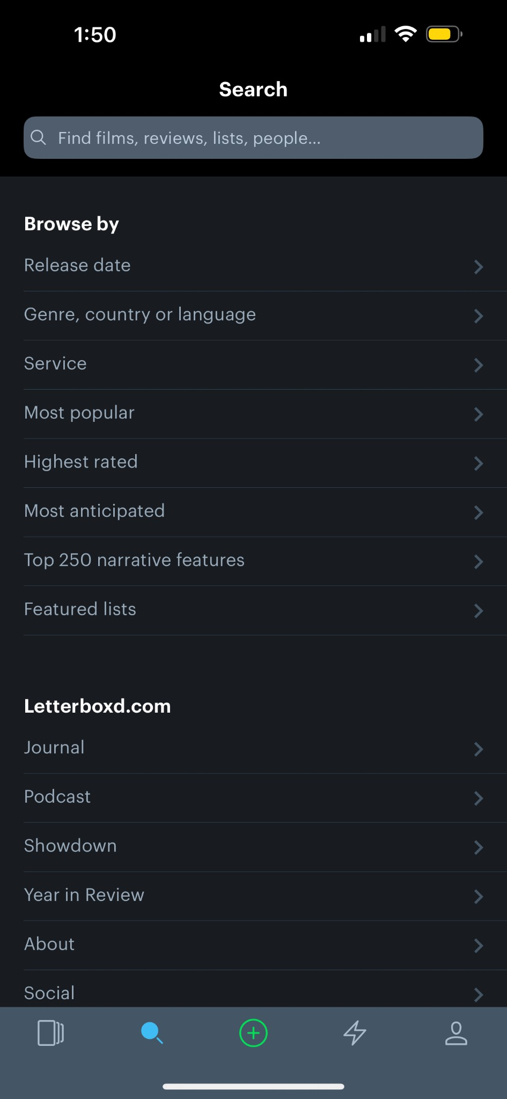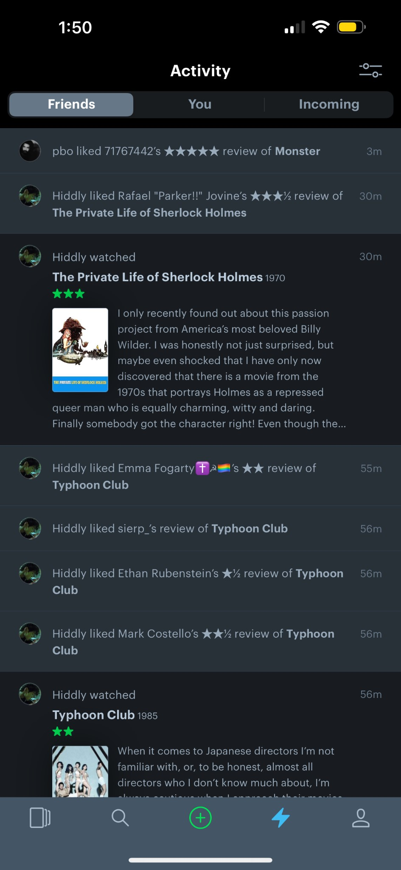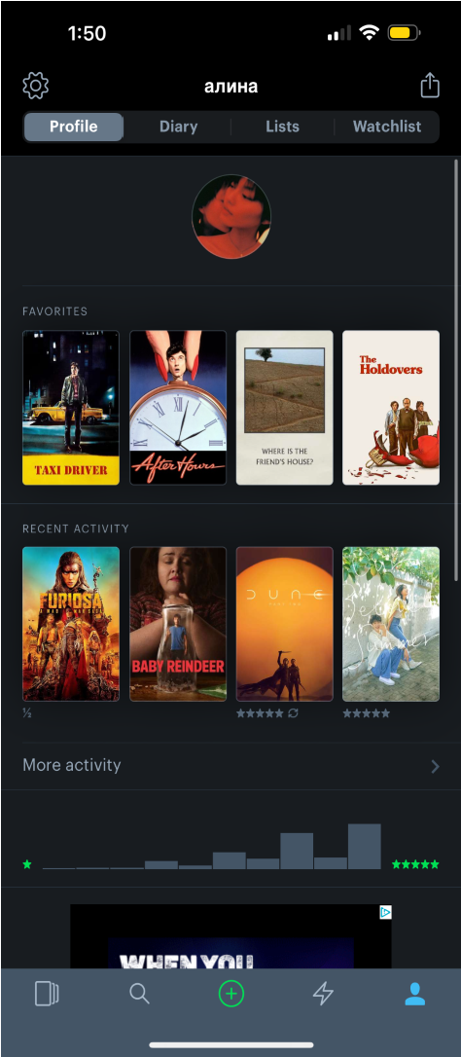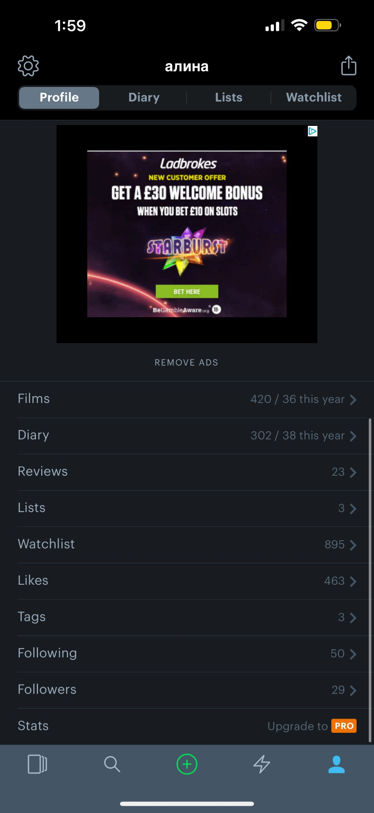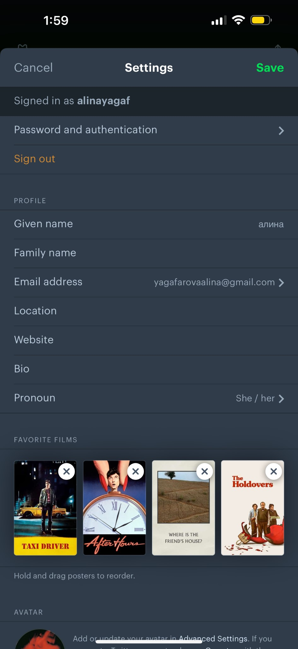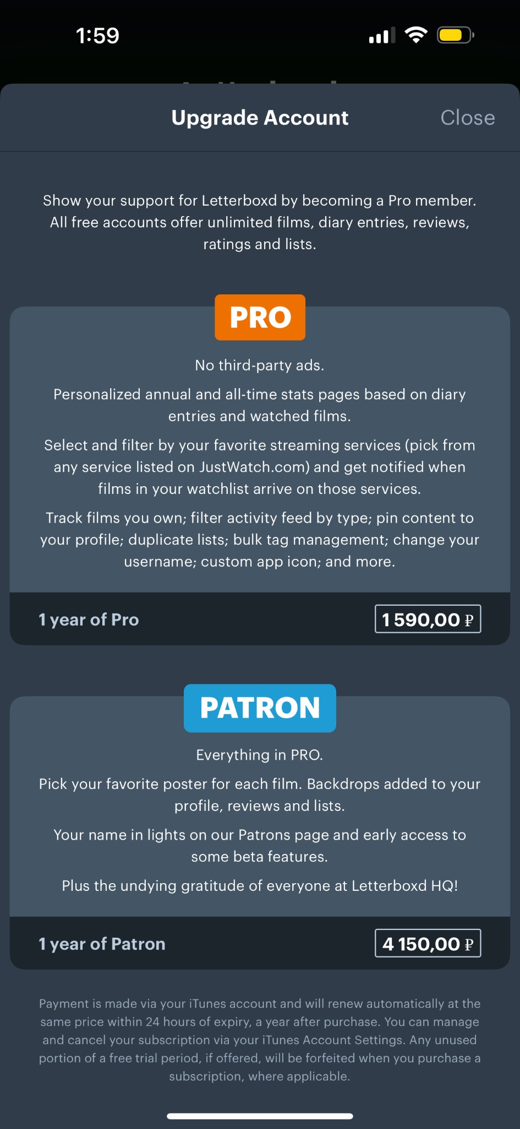

The user flow of the app is designed for intuitive navigation and easy access to various features. Upon opening the app, users are greeted with popular and trending content, ensuring their immediate engagement. The main page not only encourages users to log in the films they watched, but also to explore trending movies. Users can quickly switch between major sections like “films”, “reviews”, “lists”, and “journal”. This provides a clear and organised structure for accessing different types of content. By clicking on the poster, the app leads the user to the detailed information about the movie user review, and rating, encouraging even deeper engagement. The banner for the upgrading to the Pro version is placed prominently but not obtrusively, ensuring that users are aware of the option without interfering with the main activities. The persistent footer ensures that navigation options are always available, reducing the need to return to the home screen. Access to the user profile through the footer allows users to customise their experience, track their activity, and manage their lists and reviews, fostering a sense of ownership and being a part of the community.

The app encourages users to seamlessly explore the world of cinema by allowing users to move effortlessly from one section to another, whether they are looking at popular films, checking out friends’ activities, or navigating through their profile and lists. The flow emphasises social interaction, with features that allow users to see friends’ activities and popular content within their social circle, enhancing community engagement. The intuitive layout and easy access to various features make it simple for users to find and interact with content, contributing to a smooth and enjoyable user experience.

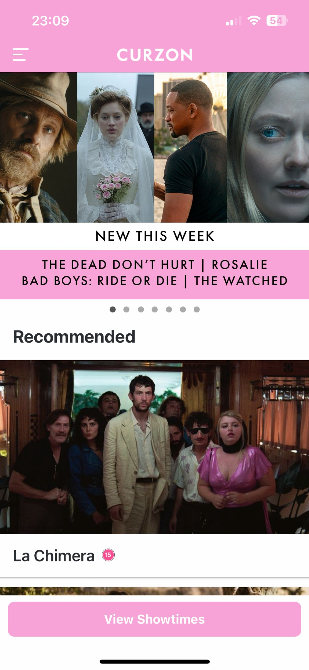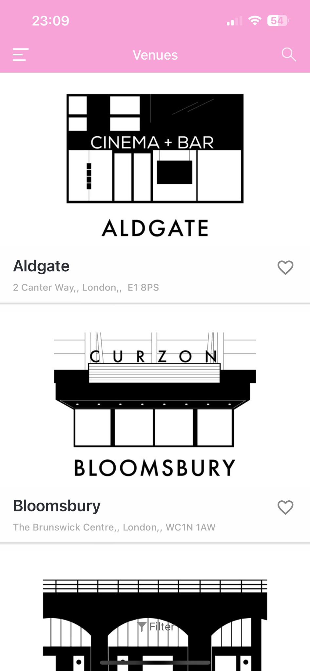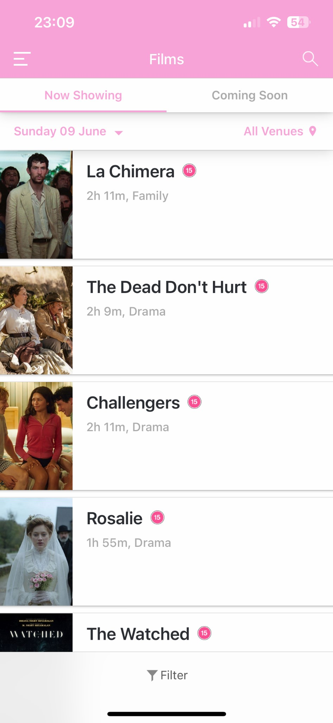

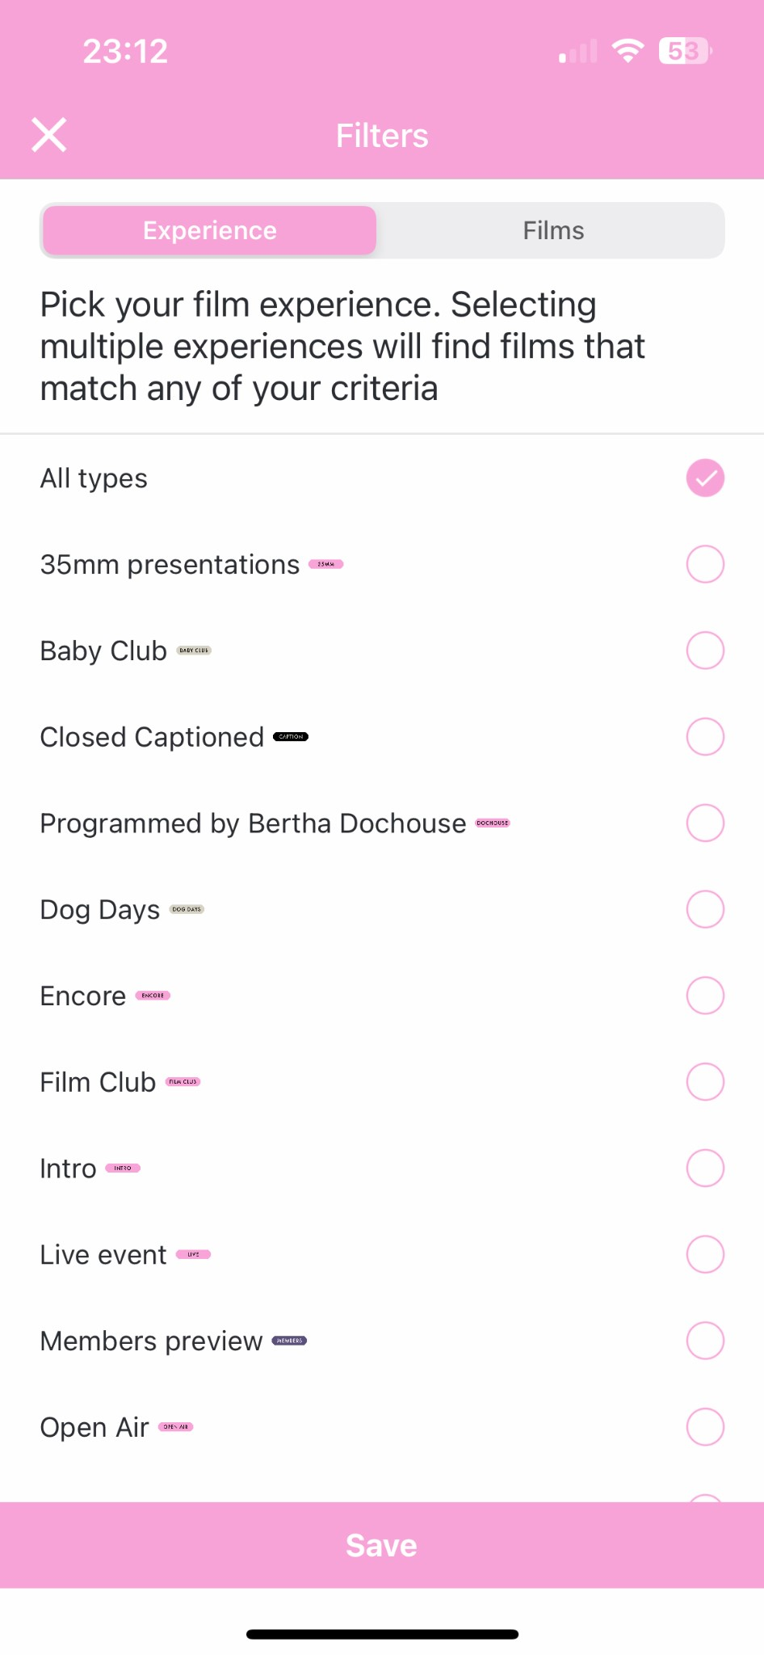

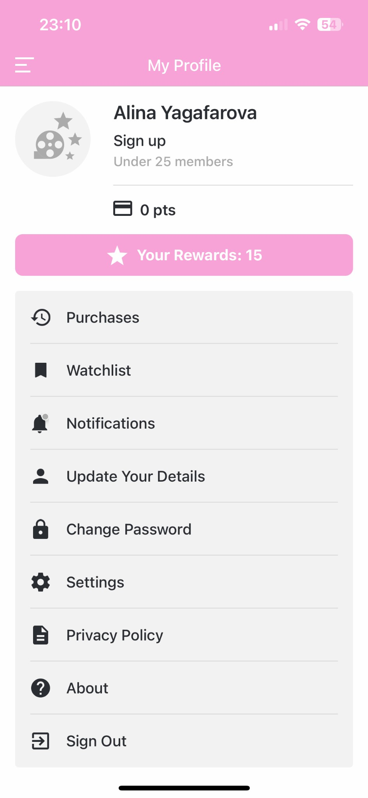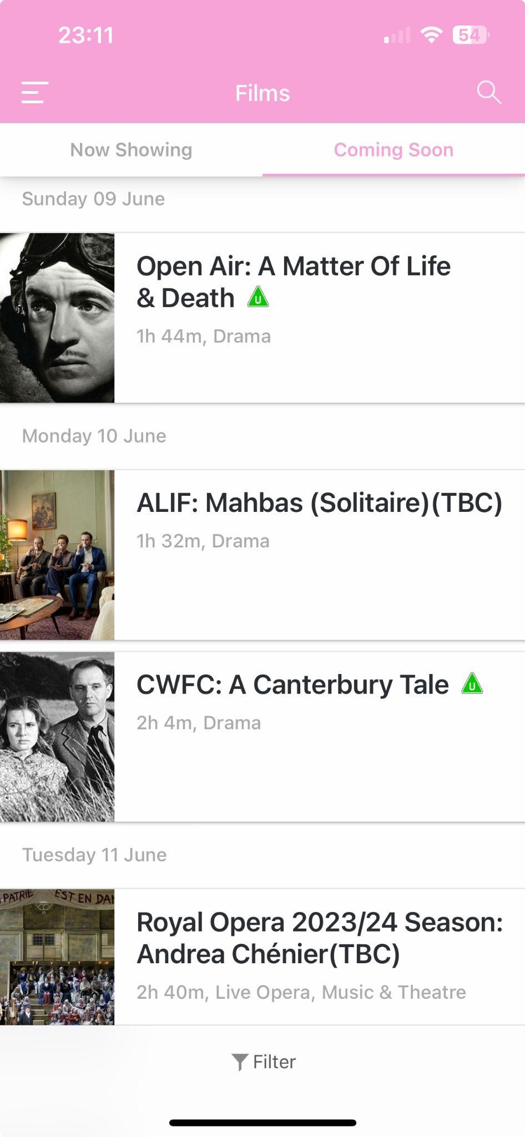

Another app, which interface and user experience I wanted to explore is the Curzon app. Curzon is a chain of cinemas across the UK. They position themselves as a place to discover other worlds and cultures or see a different perspective. It's also a place where the drinks and conversation flow in equal measure, where cinema becomes a memorable experience for a broad range of people.

The colour scheme for this app is very different from the Letterboxd one. The soft pink and white colour scheme create a visually appealing and friendly interface.

Upon opening the app, users land on a screen showcasing new releases and recommendations. This immediate display of content encourages users to explore current offerings. Users can navigate between new releases, recommended movies, and detailed film pages seamlessly. From the home screen or detailed movie pages, users can quickly find showtimes by clicking on the “View Showtimes” button, streaming the ticket booking process. The filtering options help users narrow down their choices based on preferences, making the discovery process efficient. The hamburger menu and profile section allow users to easily access account-related information and settings. This ensures that users can manage details without the hassle. The “venue” tab provides information on different cinema locations. Users can select their preferred venue, which likely tailors the showtime information to that specific location.

The app flow is intuitive, with clear sections and easy navigation. Users can quickly find and engage with the content they are interested in. The ability to filter and sort films enhances the user experience by allowing users to customise their search based on personal preferences. The use of highquality images and a visually appealing colour scheme keeps users engaged and enhances the overall aesthetic of the app. The presence of clear call-to-action buttons for viewing showtimes and booking tickets makes the process straightforward and user-friendly.

Throughout my research, I could not find any apps that have similar functionality to my idea. The apps that I did research about have some of the functionality I want to implement, but not fully. In my opinion, why separate cinemas do not have their own is primarily because of the financial aspect of implementing the app. That is why my app focuses on multiple independent cinemas around London, so that the financial aspect of the app would not be as burdensome.

*Design*

* *Prototypes*

My first design iteration was hand-drawn. I added the main functionality and some of the navigation to have a quick overview for the app. Each user has their profile page, home page and the tickets page. The profile page consists of the main information: username, profile pic, the amount of followers, the people the user is following and his film-related information (favourite films, favourite cinemas, etc.). The home page consists of three parts, articles and news, then feed from your friends (movies they watched and at which theatre). The tickets page consists of two parts, the map with all of the cinemas and the list of the films that are showing in each cinema. The functionality of my app is following:

* Book tickets on the external website by selecting the cinema and date
* Search films, rate them, read the information about them. Learn about independent cinemas as well.
* Follow friends and creators
* Access tickets to the events and send them to your friends
* Set preferences: favorite cinemas, films, etc.
* Ability to interact with the Creators by reading articles, listen to the podcast on the external app

I was also planning to implement the mailing system with customised news to each user and potentially a membership feature.

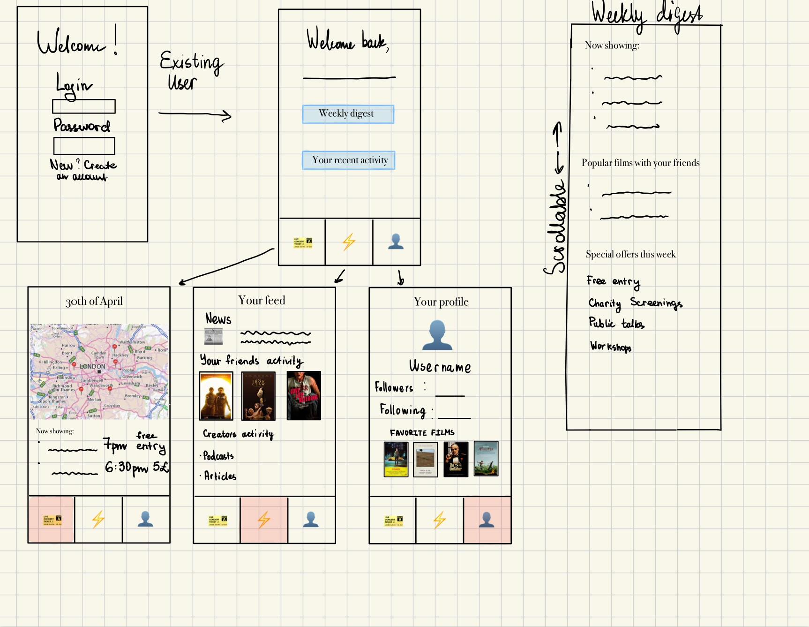

*First prototype idea*

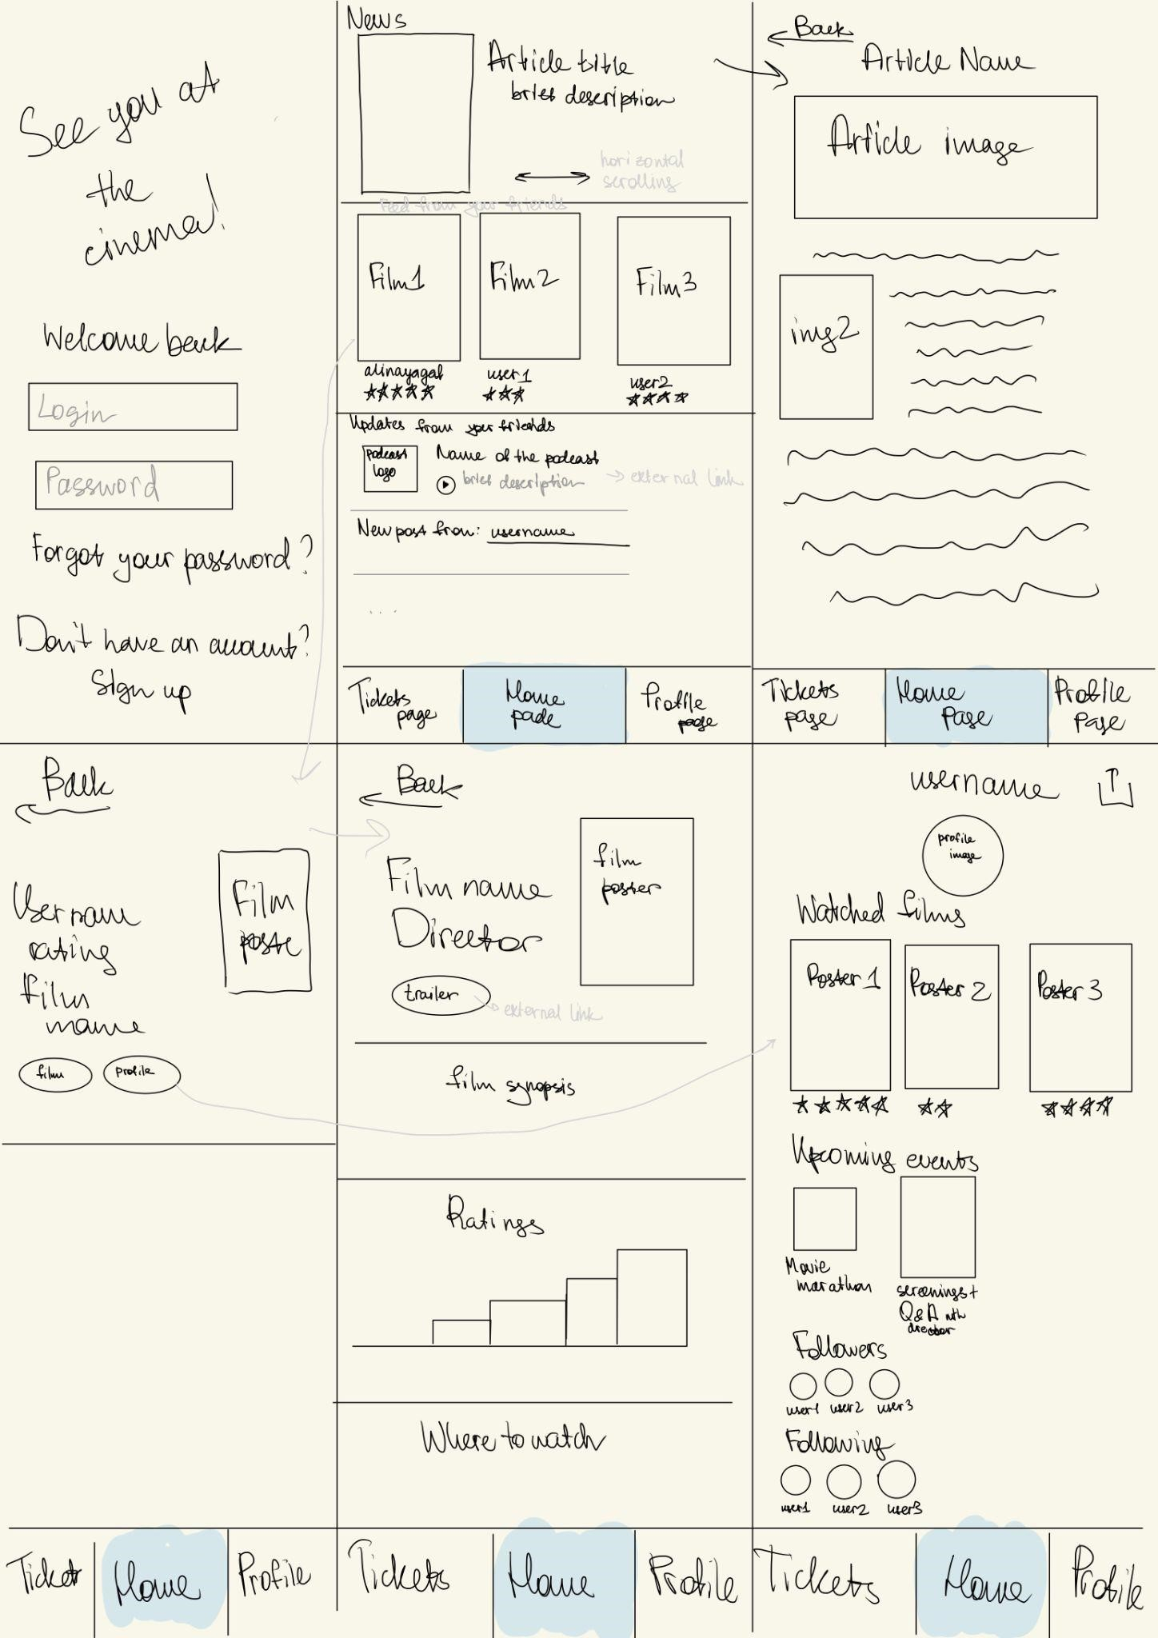

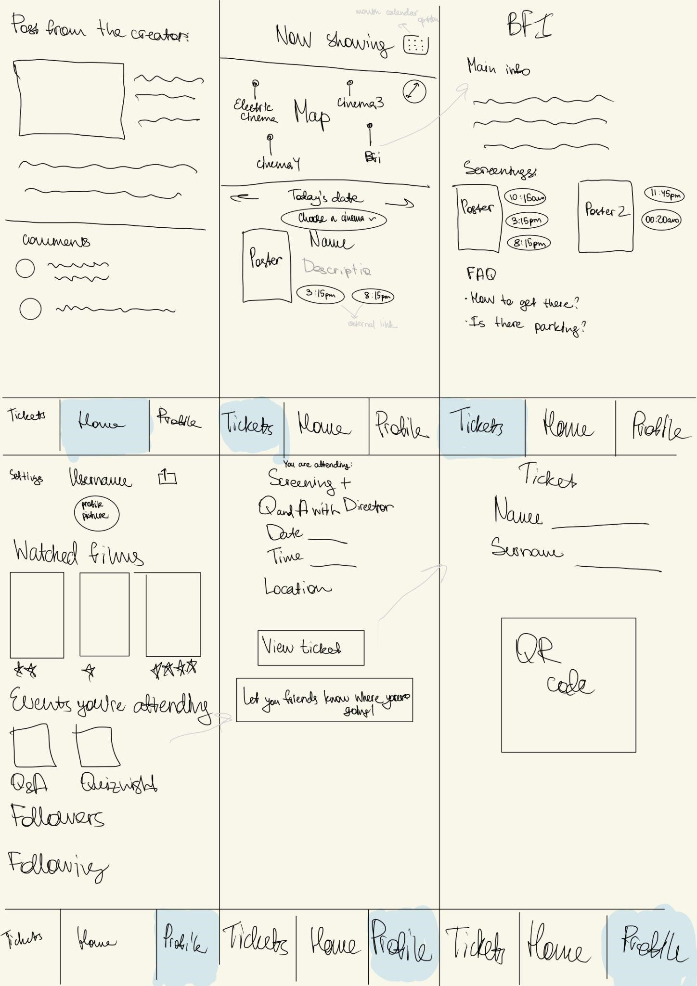

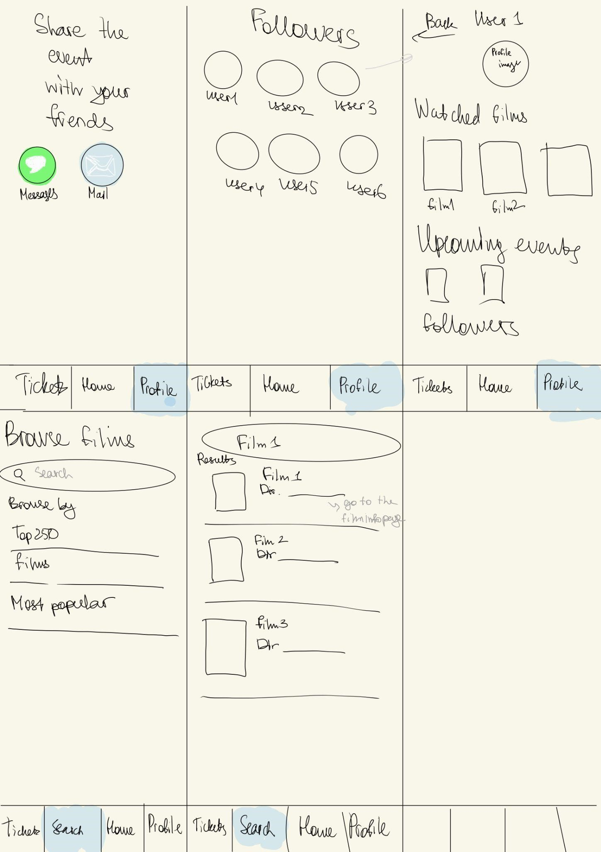

These are my hand drawn sketches of the app. When I just started coming up with the idea, I only included three tabs at the navigation menu at the bottom. After considering all of the features of the app, I decided to do 4 tabs in the end. Throughout the coding process, the functionality of the app mainly stayed as it is described in the wireframes, but I did some modifications with layout of the stuff on the screen. I also discarded the idea of having a newsletter//weekly digest in the app for the time being, because I think this should be an external feature to which the user can subscribe.

After creating the hand drawn prototype, I also made a MockUp plus prototype to show the user’s flow throughout the app:

Link to the MockUp plus: https://rp3.mockplus.com/rps/B095Gw9mLC/KomfM7HrLK

Link to UserFLow:

https://www.canva.com/design/DAGH0baq9AQ/7OeSjEFGX1xLRUhW2GlwDw/edit?utm_content= DAGH0baq9AQ&utm_campaign=designshare&utm_medium=link2&utm_source=sharebutton

The mockUp plus has some limited functionality of the app to understand the user flow (mainly buttons and movie posters). I also created a map of the Userflow based on their needs in the app to see the dynamic of users browsing the app.

After completing several iterations of my prototypes, I started coding the app. I used NativeScript in the beginning. I created the login page and the main page. The reason why I chose this layout for the home page is because of the Letterboxd app. I thought that this kind of layout is beneficial for the apps that are about cinema since the posters are very engaging.

Nevertheless, when testing my app, I encountered an error that could not be resolved. During the logging in process, when the user typed their username, which was set as “test”, and the password, which was set as “pass”, when pressing on the login button, which is supposed to check if the username and password are correct, it could not be redirected

to the next page. After some debugging, when I printed what the app was getting from the login and password section, it turned out that the outputs were concise by one last letter as shown in the picture. Not being able to resolve the issue, I decided to switch to Swift. While I was coding in NativeScript, I created a layout for the homepage based on my prototypes.

•

*Iteration process*

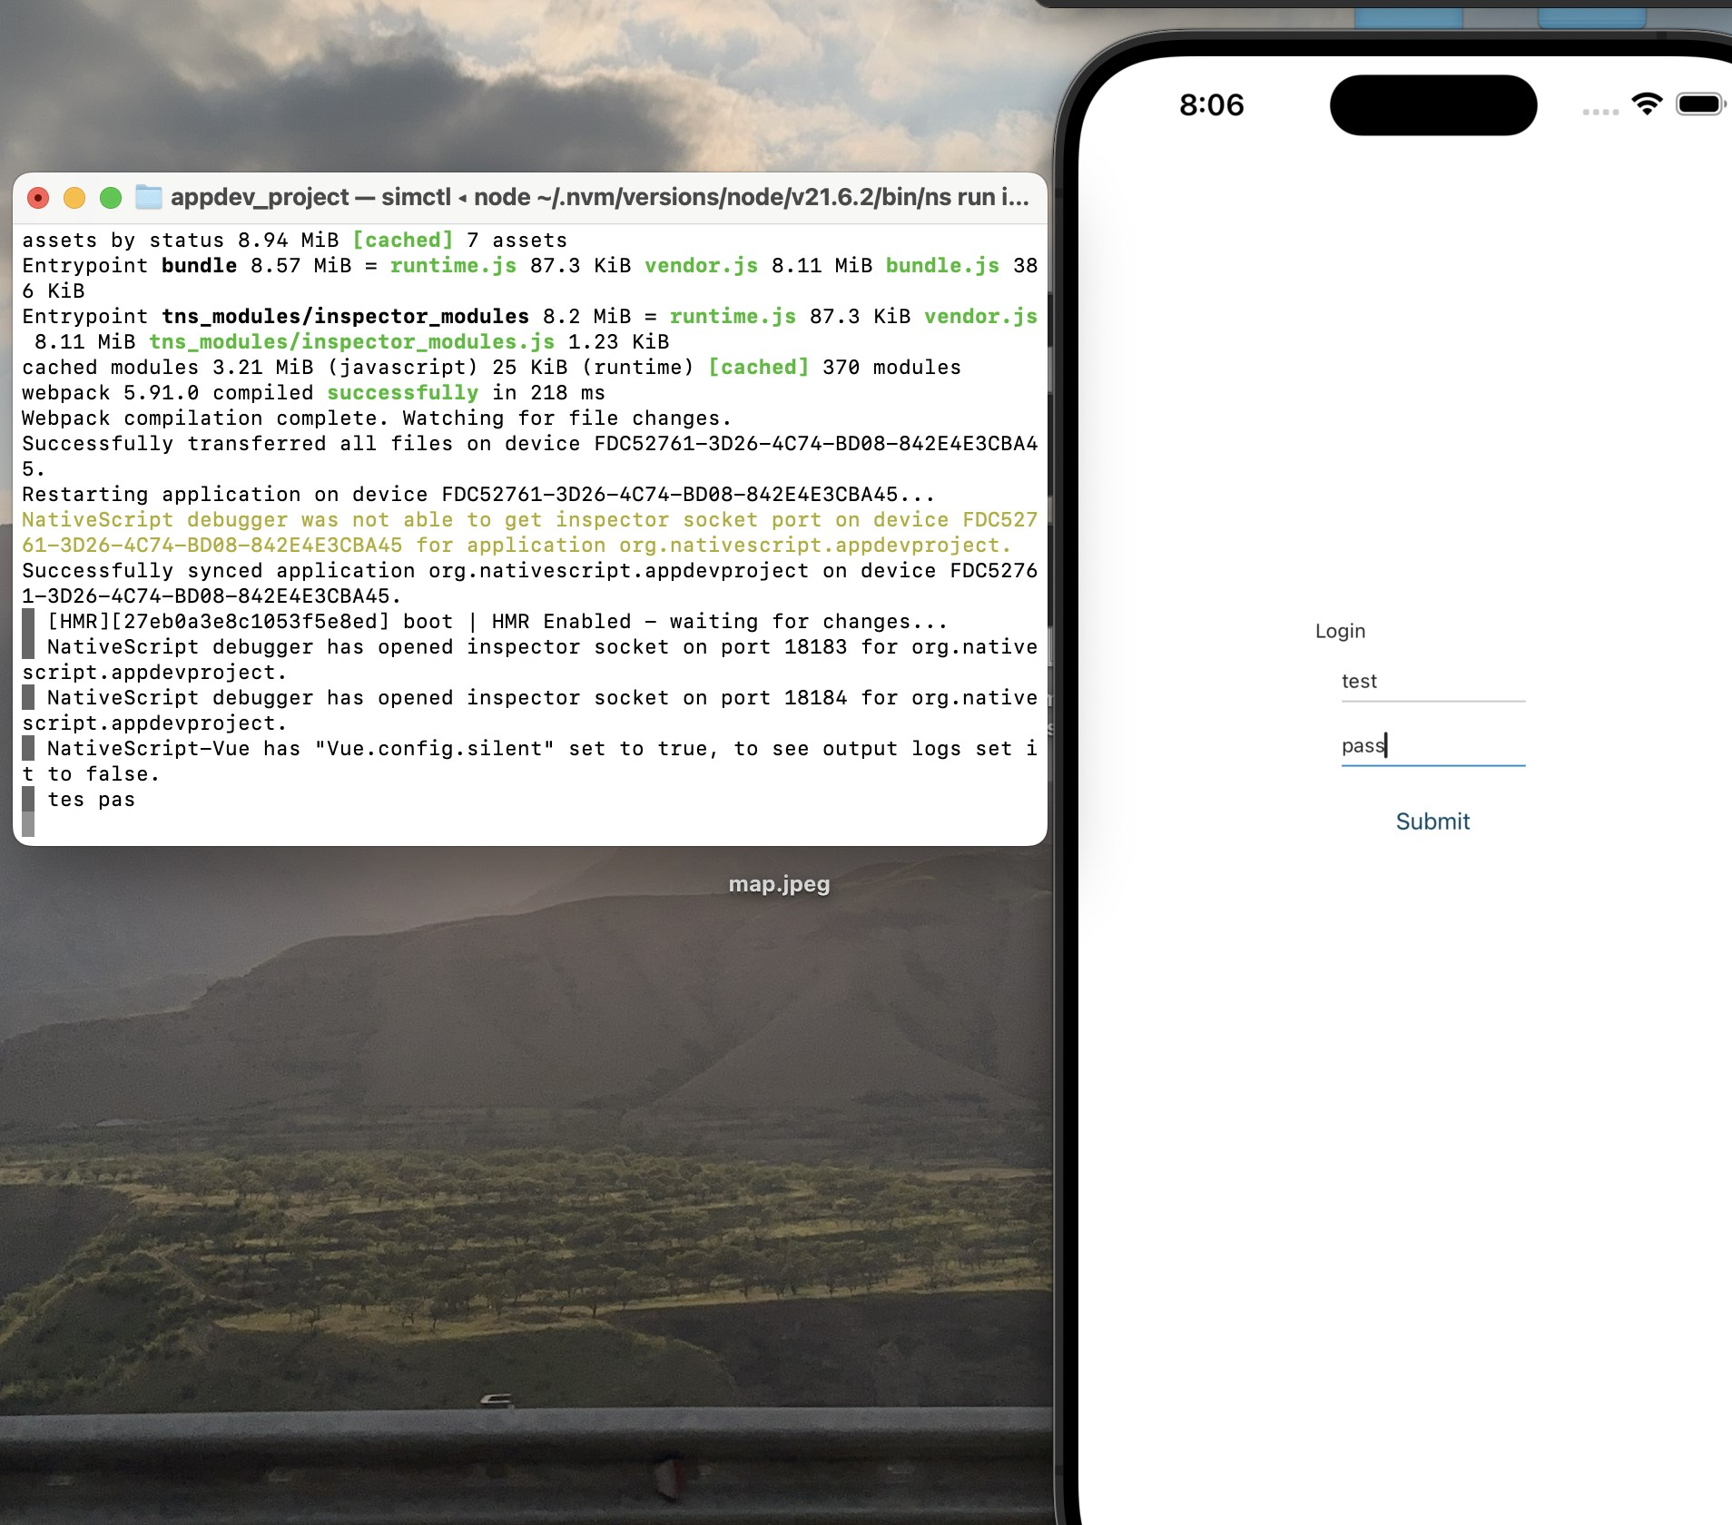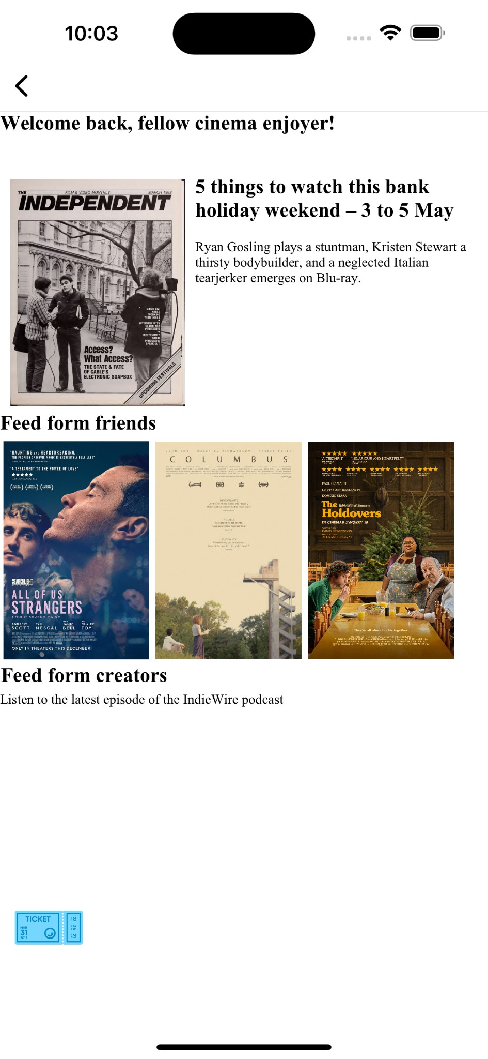

After switching to Swift, I also had some iteration of the home page. I received the feedback that the home page looks a bit “too much” and the eye of the user cannot grasp any information. I mostly was focusing on changing the layout of the articles page on top. At first, all of the sections of the app were having different types of scrolling: the articles had vertical scrolling, the friends activities had horizontal scrolling and the “from creatives” section had vertical scrolling. I received the feedback that it looked confusing, so I changed the scrolling to horizontal in the first 2 sections. Then, I experimented with the layout of the title of the article and the image and came to a conclusion that it is best to decrease the opacity of the image and the title on top of it and make it clickable.

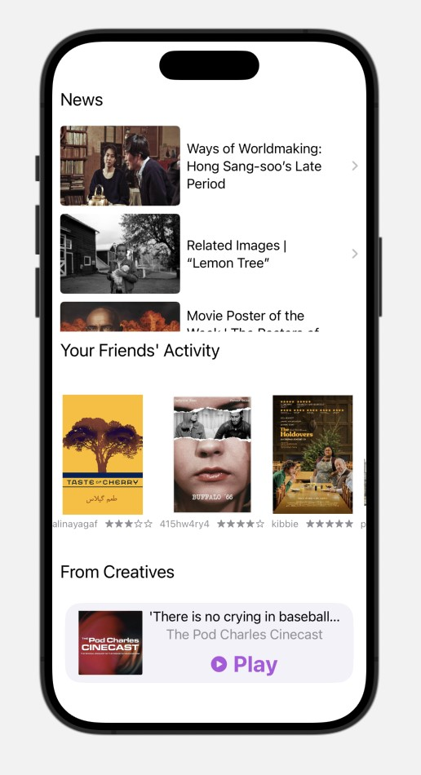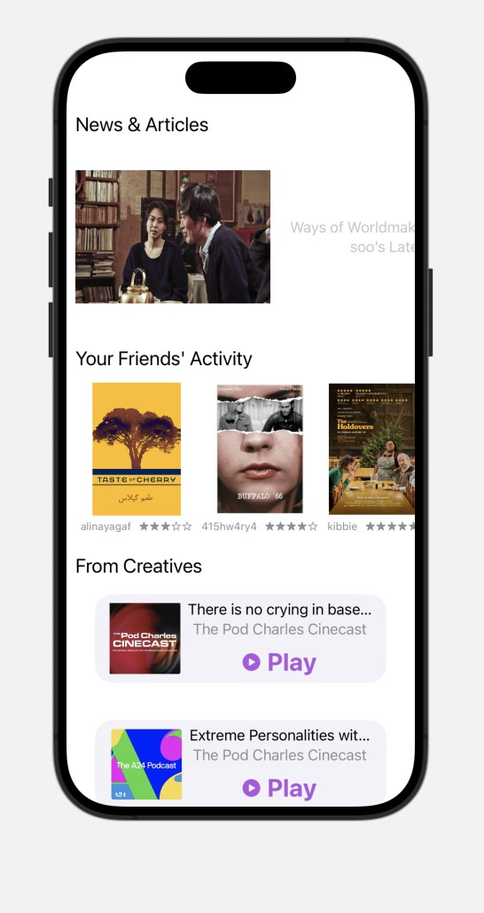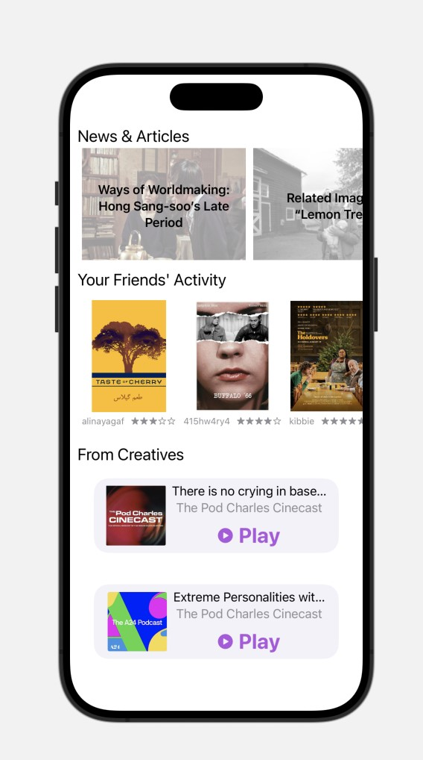

Another design layout iteration has been made in the tickets page. I wanted to make it as user-friendly as possible with the map being accessible to be clicked on. I first made a choice of film as a button and then managed to make it as a picker with options popping up, so it does not take a lot of space. Moreover, after adding padding to all of the sections the page did not look so concentrated and motley.

Besides, in terms of design, I was hesitant about what colour of the markers to choose for the map.

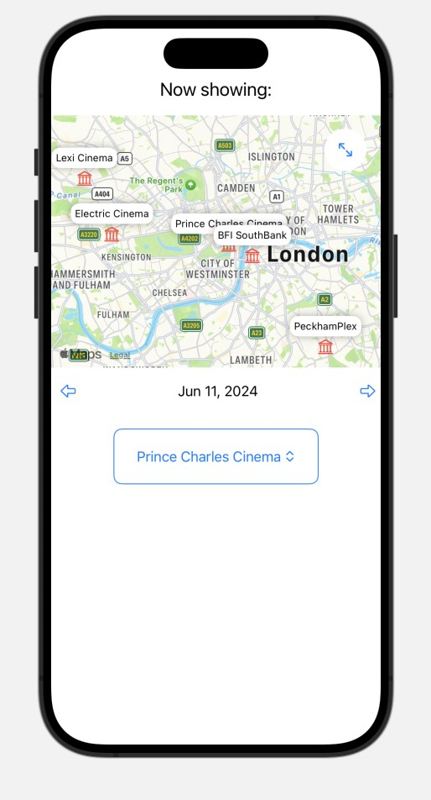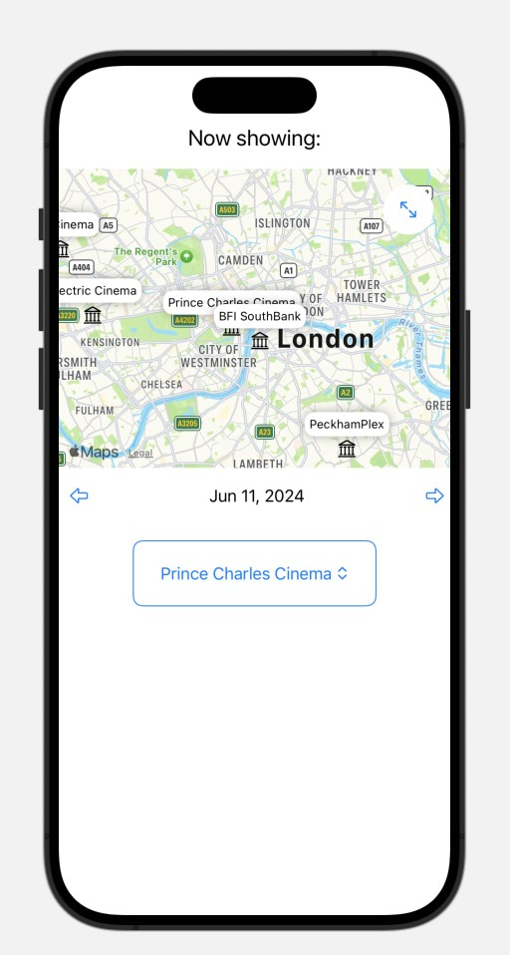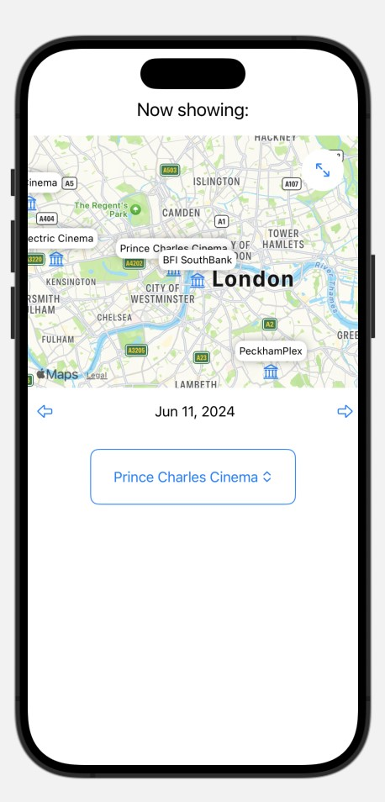

In the end, I decided to go with the red colour since it’s more visible.

Here are the screenshots of the main pages of the app:

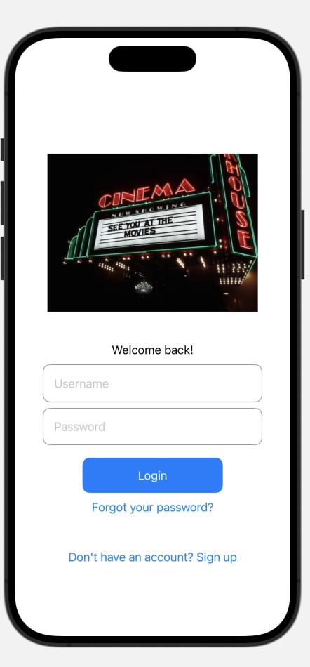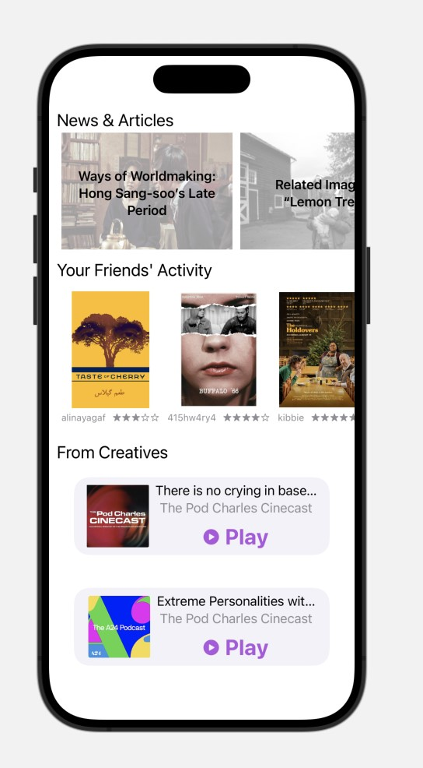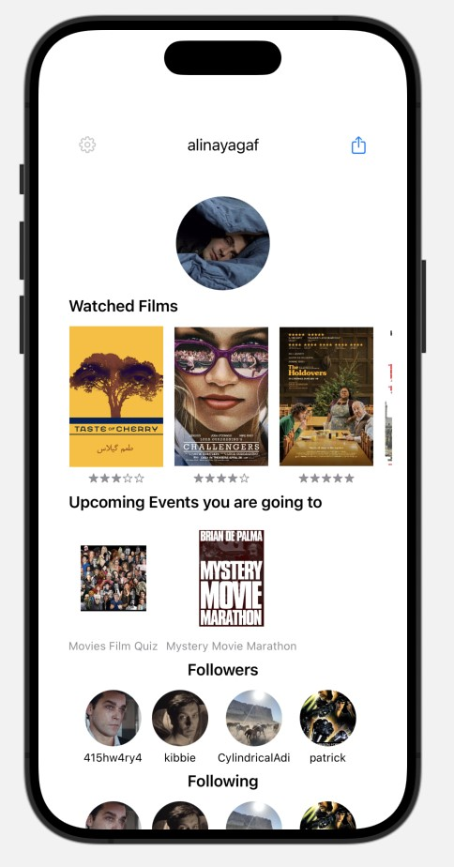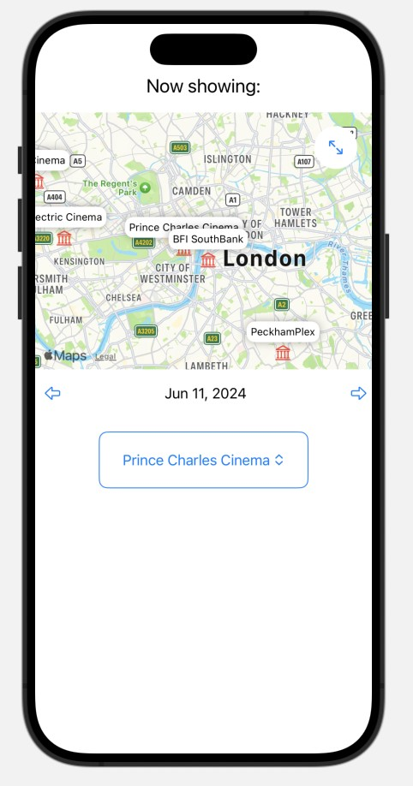

For demonstrating the functionality of the app, I added “test” layouts. The

User experience flow is pretty intuitive where clear labels and icons help

users understand the functionality of different sections without needing

extensive explanatio

ns.

After coding the main part of the app, I decided to add some of the

more complex functionality. For example:

1.

In the profile page, I added the “UPcoming Events you are going

to” section. When clicking on the event it redirects you to the page

with i

nformation of the event, the ability to see the ticket and ability

to share the event with the friends of the app. This feature, in my

opinion, boosts community engagement. I used chatGpt

-

3

to

understand the concept on how to implement the functionality of

inviting friends by text them a pre

-

created message about attending

the event.

Additionally, I used it to figure out the search bar in the search

pag

e

.

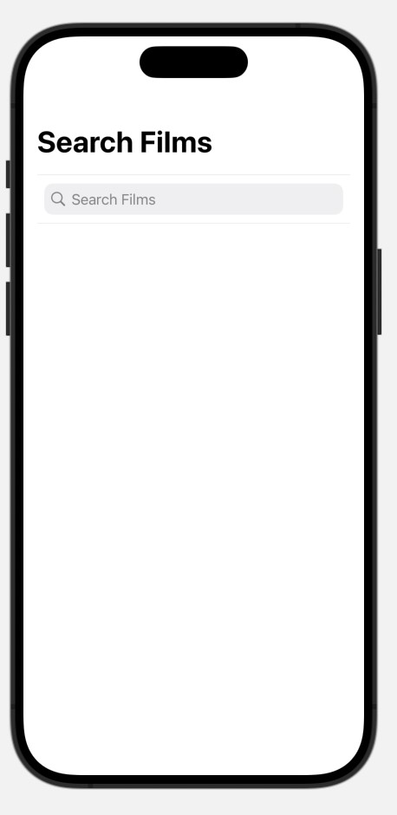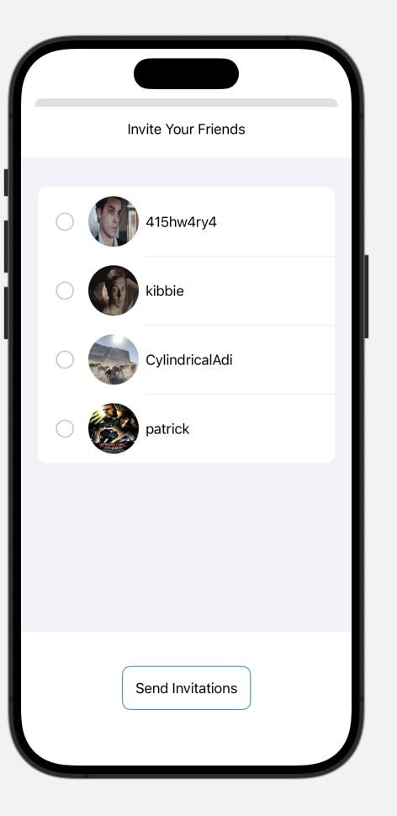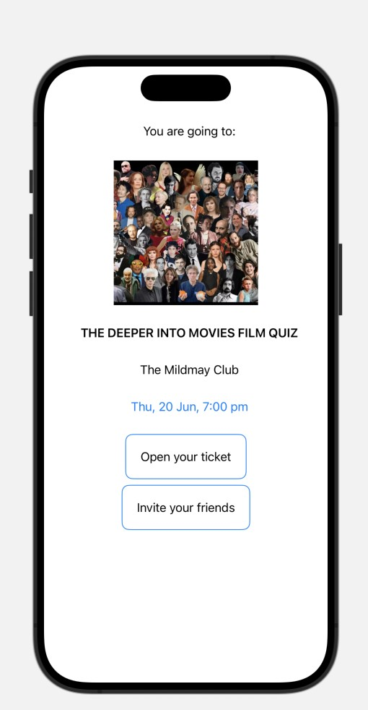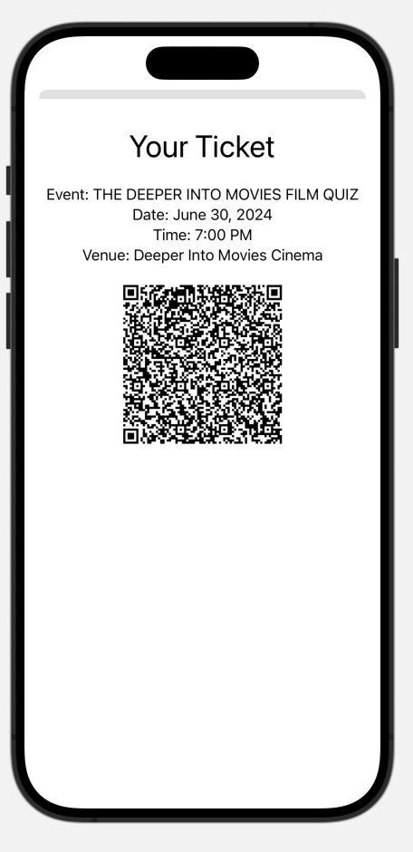

1. Most of the buttons lead to external links, e.g. booking system on the website or link to listen to the podcast. Since my app only gathers around all of the independent cinema, I didn’t implement the internal booking or payment systems.

For displaying most of the information (as in user’s, film’s, carousel etc.) I used Data structures in Swift. I created a dataset that consisted of variable, so I can sue them multiple times on different pages. After creating the dataset, I created the page with the layout of the used dataset (image, username, rating, etc.). This was a very helpful structure to use across different pages.

1. *App Icon & Name*

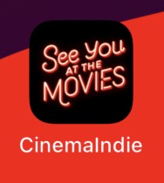

I decided to name the app “CinemaIndie'', because of the purpose the app serves: providing more access to the independent cinema, fostering the feeling of the community.

I decided to go with the minimalistic style of the app, where it says “see you at the movies”. The font is neon script style, which is commonly associated with retro and vintage signage. This style of font is often used in cinema signs, particularly in classic and independent cinemas, to evoke a nostalgic feeling and create a visually appealing atmosphere.

*Future Implementation*

In terms of future implementation of the app, I think it would be interesting to integrate the pro version of the app that gives more personalised recommendations, discounted tickets and membership to use at different cinemas. Besides, I think it would be interesting to see the more complex functionality of the app: for example, in the tickets page, it would be nice to see the interactive map. When the user clicks on the chosen movie, the cinema he chose to watch, gets highlighted in another colour. Also, when clicking on the pins on the map, it would be nice to be redirected to the page about basic information about the cinema, like directions, screenings etc.

Even though I demonstrated the demo version of the app, because I did not create all the pages, so in the code some of the pages might be conflicting with each other, because they are redirected to the same page. (for example, the profile page of the user, when clicked on the film, will be redirected back to the initial profile page of the user who is logged in).

I would also work more on the design aspect of the app, choosing specific fonts and main colours of the app. Right now, the app looks very minimalistic with very little design decisions. I would also consider 2 modes of the app: dark mode and light mode.

*Bibliography*

1. *Gusfield, J. (1975). Community: A Critical Response. Oxford: Blackwell.*
2. *Londoner, S.E. (2023). 'A data analysis of the London cinema industry', South East Londoner, 4 May. Available at: https://www.selondoner.co.uk/entertainment/04052023-londonscinemas-data-2022-film-industry .*
3. *Independent Cinema Office (2023). Financial health of the theatrical film exhibition sector. October. Available at: https://ico-assets-live.s3.eu-west-1.amazonaws.com/wp-*

*content/uploads/2023/10/11142516/Financial-health-of-the-theatrical-film-exhibition-sectorreport-Oct23.pdf (Accessed: 11 June 2024).*

1. *Chrysostomou, G. (2023). 'Why you should support your local independent cinema', Reader's Digest, 3 October. Available at: https://www.readersdigest.co.uk/culture/why-you-shouldsupport-your-local-independent-cinema*